Harry Francois Stein, Jr.
April 8, 1934 – February 10, 2012

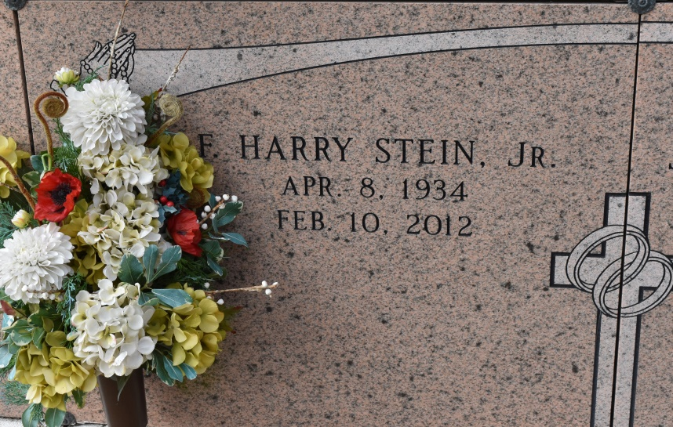

Harry Francois Stein Jr. - A loving husband, father, grandfather, and brother, he passed away on Friday, Feb. 10, 2012, at age 77, surrounded by his family. He was a native and resident of Union, and a parishioner of St. Michael's Catholic Church. He was known as 'The Hawk' by his community and friends. He loved coffee mornings at Hymels, family gatherings, Red Sox and LSU Baseball, riding in the cane fields, yearly retreats at Manresa, and Saturday morning breakfasts with his sons-in-law.
He is survived by his bride of 51 years, Janice Chauvin Stein; son, Sandy Joseph Stein; daughters, Sebrina Rome and husband Ron, Fran Fleniken and husband Mel, Anne Marie LeBlanc and fiancé Ben Fields; brothers, Roland P. Stein and wife Madge, and Roy J. Stein and wife Bobbie; sister-in-law, Kathy Stein; and grandchildren, Amanda and Melissa Rome, M. Kade and Alexa Fleniken, Ayrton and Harrison Stein, Auldyn and Anna LeBlanc, Emily and Kate Fields.
Preceded in death by parents, Leona Falgoust and Harry Francois Stein Sr.; brother, Donald J. Stein Sr.; and a niece, Ella Marie Stein.
Visitation at St. Mary's Catholic Church in Union on Tuesday, Feb. 14, from 10 a.m. until a Mass of Christian Burial at 1:30 p.m., with the Rev. Ed Fuss, celebrant. Entombment in the church cemetery. Pallbearers will be Roland "Buddy" Stein Jr., John Stein, Kade Fleniken, Ayrton Stein, Ron Rome, Mel Fleniken and Ben Fields.
The family would like to give thanks to the supportive staff at St. Elizabeth Hospital and Our Lady of the Lake Regional Medical Center. We would also like to express our great appreciation to Doctors M. Hebert, M. McCarthy, and J. Cefalu for their care and guidance. To our family friend, Lana Stewart, we are deeply grateful for your care and compassion.
Memorial donations may be made to St. Michael's Catholic Church in Convent. To offer condolences to the family, please visit www.oursofh.com.
The Advocate (Baton Rouge, LA)
Feb. 12 to Feb. 14, 2012

