Janice Louise (Chauvin) Stein
November 7, 1938 – July 21, 2017

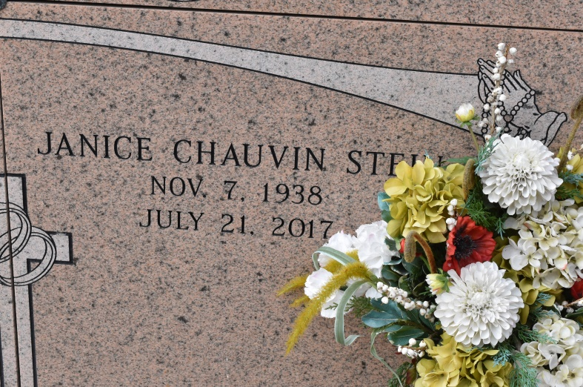

Janice Louise Chauvin Stein, a native and resident of Union, passed away Friday, July 21, 2017 surrounded by her family. Remarkable beyond words, she was a devoted mother, grandmother, great-grandmother, sister, aunt, and friend. She somehow managed to give everyone in her life her undivided attention.
She is survived by her loving children, Sebrina Rome and husband Ron, Fran Fleniken and husband Mel, Sandy J. Stein, and Ann Marie Fields and husband Ben; brother Harry Chauvin and wife June Rose, and sister Adele Schexnaydre and husband Glenn. Affectionately known as Maw by her adoring grandchildren (her kings and queens); Amanda Rome, Melissa Rome Brunet and husband Ryan, Kade Fleniken, Alexa Fleniken Butcher and husband Daniel, Auldyn and Anna LeBlanc, Ayrton and Harrison Stein, and Emily and Kate Fields. She celebrated the birth of her first great-grandchild, Jude Brunet, this summer. They all brought her joy beyond measure.
She was preceded in death by her husband of 51 years, Harry F. Stein, Jr. Also preceded by her parents, Wilbert and Neola Chauvin; brother, Larry Chauvin; nephews Hoyt and Craig Chauvin; and nieces Dorna Chauvin Elfer and Ella Stein.
Visitation at St. Mary's Chapel (LA 44) in Union on Thursday, July 27 from 10:00 am until a Mass of Christian Burial at 1:30 pm with Father Vincent Dufresne, celebrant. St. Michael's choir will recite the rosary at noon. Entombment will be in St. Mary's Church Cemetery. Pallbearers will be her grandsons and sons-in-law; Kade Fleniken, Ayrton and Harrison Stein, Ron Rome, Mel Fleniken, and Ben Fields.
To our family friend, Lana Stewart, we are forever grateful for your steadfast friendship, care, and compassion. Memorial donations may be made to St. Michael's Catholic Church in Convent. Arrangements under the direction of Ourso Funeral Home, Gonzales, LA.
Ourso Funeral Home, Ascension Parish, LA
December 19, 2020

