Ashton Carl Stockton
September 12, 1939 – December 7, 2007

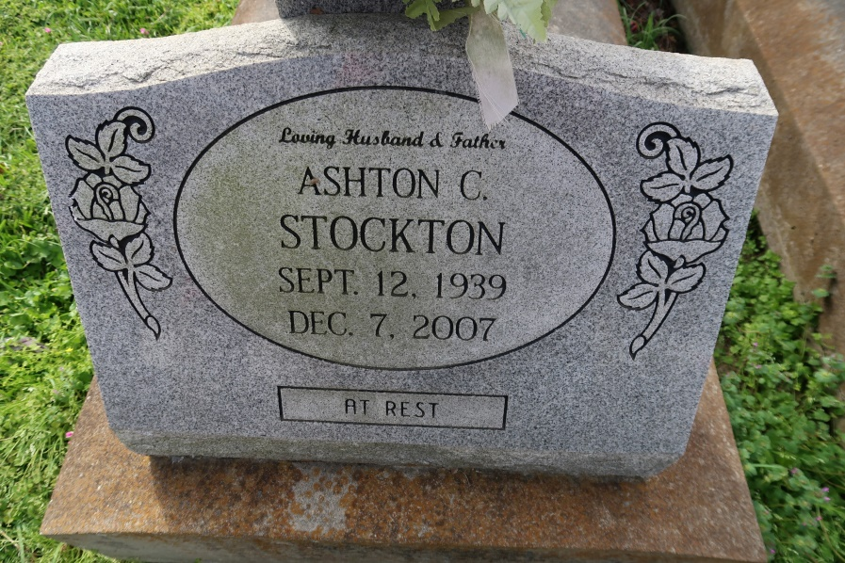

Ashton C. Stockton - A retired electrician with Local 130 and a resident of Convent, Ashton Carl Stockton died Friday, Dec. 7, 2007, at St. James Hospital. He was 68 and a native of Biloxi, Miss. He served in the U.S. Army Reserve.
He is survived by his wife of 24 years, Ferrell Ann Stockton; four sons, Jimmy, Billy, Terry and John Stockton; three stepchildren, Rachel Broussard and Kim and Jory Chauvin; two sisters, Ruth Schrumpf and Betty Fletcher; a brother, Robert Stockton; seven grandchildren and a great-grandchild.
He was preceded in death by his father, James Stockton; mother, Audrey Quave Stockton; and a brother, Monte Stockton. Arrangements entrusted to Alexander Funeral Home, Lutcher. Interment in St. Mary Catholic Church Cemetery, Union. First marriage to Bonnie Jane O'Neal, 10 Dec 1962, marriage ended in divorce, c. 1982. Second marriage to Ferrell Ann, no children.
The Advocate, Baton Rouge, Louisiana
December 8, 2007

