Ferrell Ann (Millet) Stockton
December 15, 1938 – Febrary 3, 2012

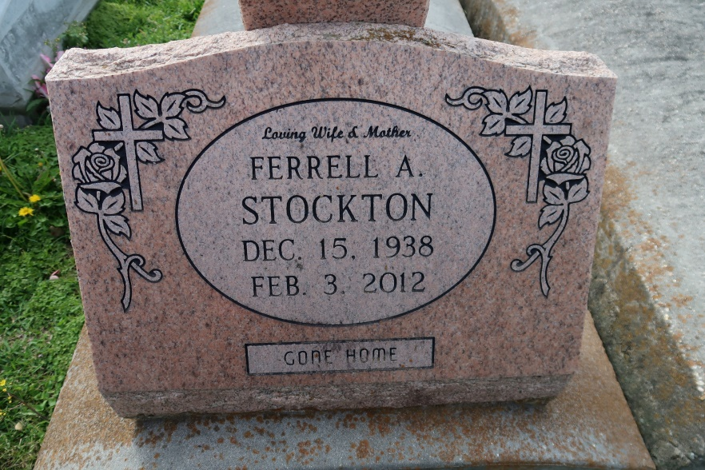

Ferrell Ann Chauvin Stockton entered into eternal rest on Friday, February 3, 2012 at 11:06PM. Age 73 years, a native of Convent, LA and a resident of St. Amant, LA for the past 4 years. Beloved wife of the late Ashton Stockton. Loving mother of Rachel Hoven and husband Robert, Jory Chauvin, Kim Guedry, and the late Dorna Elfer, and Hoyt Chauvin. Stepmother of Jimmy, Billy, Terry, and Jon Stockton. Daughter of the late Leonce and Emeline Duhe Millet. Sister of Eunice Melancon, Audrey St. Pierre, Lavonne Brady, Leonce Millet, Jr., Arthur Millet, and the late Louise Lemoine, Florence Porta, Helen Brady, Doris Vicknair, Joseph C. Millet, and Robert Millet. Also survived by 10 Grandchildren, and 5 Great Grandchildren.
Relatives and friends of the family are invited to attend the visitation at H. C. Alexander Funeral Home 2208 Jefferson Hwy, Lutcher, LA on Wednesday, February 8, 2012 from 6:00 PM until 9:00 PM, and again on Thursday morning, February 9, 2012 from 10:00 AM until 12:45 PM at St. Michael the Archangel Catholic Church, 6490 Hwy 44, Convent, LA. A Funeral Mass will be celebrated at 1:00 PM with Rev Vincent Dufresne, officiating. Interment will be in St. Mary's Cemetery, Union, LA. Condolences may be offered www.hcalexanderfh.com
Ferrell Stockton Obituary - Lutcher, LA (dignitymemorial.com)

