Earl Lawrence Theriot, Sr.
February 13, 1924 – July 19, 2014

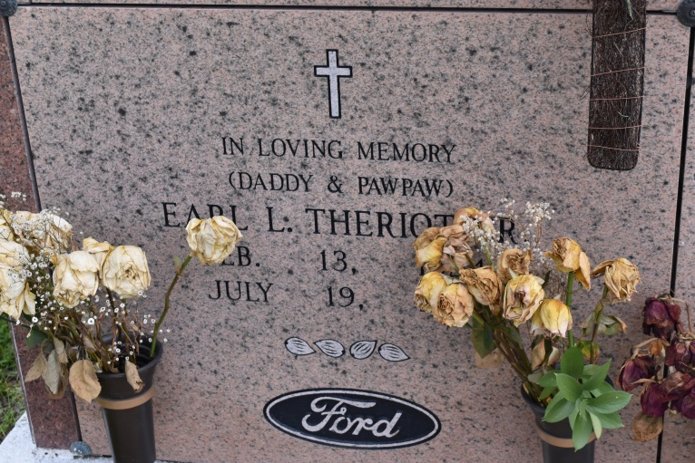

Earl Lawrence Theriot, Sr., age 90, passed away on July 19, 2014 at his residence with his family at his side. He went peacefully to Heaven to be with the rest of the family's loved ones. He was a native and resident of Union, LA.
He is survived by his sons: Robert "Butch" Theriot, Earl Theriot, Jr. (Debra), and a daughter Anita T. Delhommer; a sister, Hazel Babin, 9 grandchildren and numerous great-great grandchildren.
He was preceded in death by his spouse, Willa Mae Theriot and his parents: Charles and May Melancon Theriot; a daughter, Bonnie Sue Theriot; brothers: Lucien, Thomas, and Garland Theriot; and a sister, Aldonia Theriot.
Visitation will be on Tuesday, July 22, 2014 from 5:00 p.m. until 9:00 p.m. at Rose Lynn Funeral Services, 1870 Cabanaose Ave., Lutcher, LA. Visitation will resume at the funeral home on Wednesday, July 23, 2014 from 8:00 a.m. until 10:30 a.m. followed by a Mass of Christian Burial at St. Michael Catholic Church in Convent, LA. Burial follows in St. Mary Cemetery, Union, LA. Pallbearers will be Larry Theriot, Shane Theriot, Keith Theriot, Tyler Theriot, Matthew Green and Billy Ernest. Honorary pallbearers will be James Wilson and Cody Fonte.
He enjoyed the outdoors and taking care of his pecan trees with his faithful companions by his side (his beloved dogs). To sign and read the family guestbook, please visit www.roselynnfuneralhome.com.
The New Orleans Advocate (LA)
Jul. 20 to Jul. 21, 2014

