Andrew Gerald Thompson
November 7, 1935 – June 26, 2003

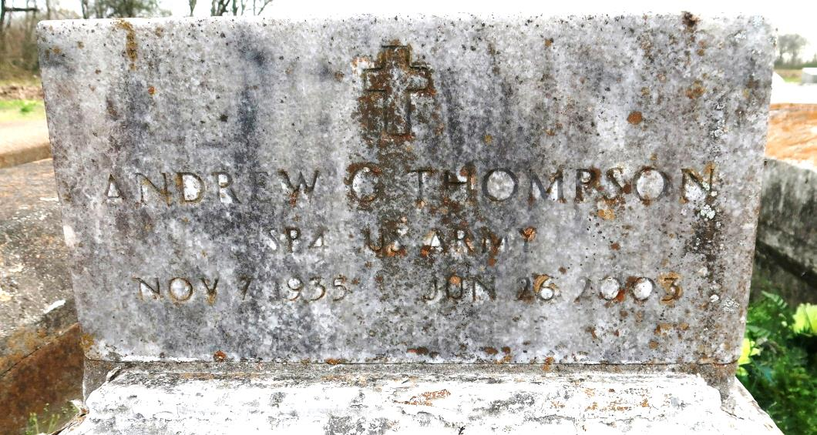

Andrew Gerald Thompson - Son of the late Freddie Thompson and Irma Benn. Brother of Katherine Darville, Betty T. Barnum and Delores T. Norman, all of New Orleans, LA. Devoted friend of Varie Stewart of Convent, LA. Also survived by a number of cousins, other relatives and friends. He was a retired supervisor for Agrico-Faustina Chemical Company. Age 67. Visiting at St. Mary's Catholic Church, Convent, LA on Tuesday, July 1, 2003 from 9:00 A.M. until Mass of Christian Burial at 11:00 A.M. conducted by Father Frank Uter. Interment in church cemetery. Brazier-Watson Funeral Home in charge of arrangements.
Unknown source
*****
Andrew G. "Andy" "Ba-Low" Thompson, a retired supervisor for Agrico-Faustine Chemical Co. in Donaldsonville, died Thursday of congestive heart failure at Our Lady of the Lake Hospital in Baton Rouge. He was 67. Mr. Thompson was a lifelong resident of Convent. Survivors include three sisters, Katherine Darville, Betty T. Barnum and Delores T. Norman, all of New Orleans, and a companion, Varie Mae Stewart. A Mass will be said Tuesday at 11 a.m. at St. Mary's Catholic Church in Convent. Visitation will begin at 9 a.m. Burial will be in the church cemetery. Brazier-Watson Funeral Home is in charge of arrangements.
Times-Picayune, The (New Orleans, LA)
Monday, June 30, 2003
Contributed by Jane Edson

