Marian (Troxclair) Waguespack
March 10, 1926 – May 29, 2008

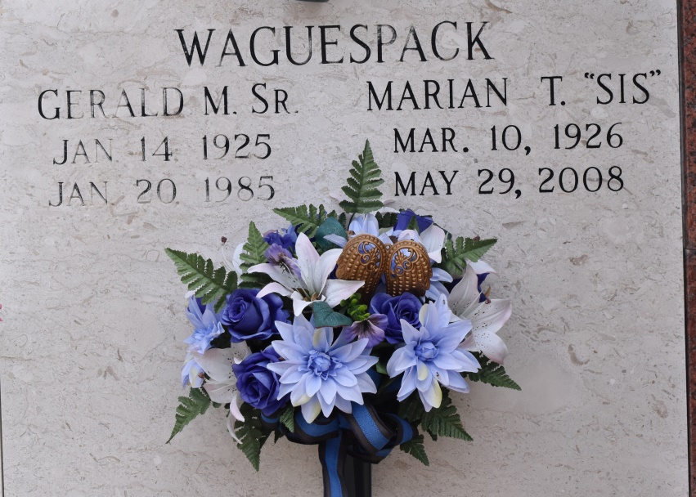

A loving mother, grandmother, great-grandmother and homemaker, she died at 5:30 p.m. Thursday, May 29, 2008, at her home in Gonzales, with her children at her bedside. She was 82 and a native of Bayou Goula.
Visiting at Ourso Funeral Home, Gonzales, on Sunday, June 1, from 5 p.m. to 9 p.m. Visitation at St. Ann Catholic Church in Sorrento on Monday from 8 a.m. until a Mass of Christian Burial at 10 a.m. Interment at St. Mary Catholic Church in Union.
She is survived by her sons and daughter-in-laws, Gerald and Anita Waguespack and Durward "Blue" and Penny Waguespack; daughters and sons-in-law, Genie and Louis Latino, Nevil and Myles Schexnaydre, Paula and Randy Bourgeois Sr., and Roberta and Danny Robichaux; grandchildren, Philip Waguespack, Aaron Bateman, Gerri Bowler, Jessica Thomassee, Matthew Latino, Alan and Andy Schexnaydre, Randy Bourgeois Jr. and Jeanette Schexnaydre, Jeffrey, Jay, Danielle Robichaux; stepgrandson, Derek Braud; great-grandchildren, Madelyn, Tatum Thomassee, Corin Waguespack, Brady Bateman, Aidan Robichaux; two brothers and sisters-in-law, Paul and Faye Troxclair and Marc and Marcy Troxclair; and brothers-in-law and sisters-in-law, Richard and Myrtle Waguespack and Hubble and Georgeann Robert.
Preceded in death by her husband, Gerald M. Waguespack Sr.; son, Gerald M. Waguespack Jr.; father, Maurice Troxclair; mother, Georgine Troxclair; stepmother, Lelia Troxclair; brother, Leonard Troxclair; and father-in-law and mother-in-law, George and Pauline Waguespack.
The family would like to thank St. Joseph Hospice, Dr. Erwin, Dr. Castine, and all friends and family for the loving support at this difficult time.

The Advocate, Baton Rouge, Louisiana
May 31 to Jun. 1, 2008.

