Myrtle (Gautreau) Waguespack
November 12, 1930 – August 31, 2020

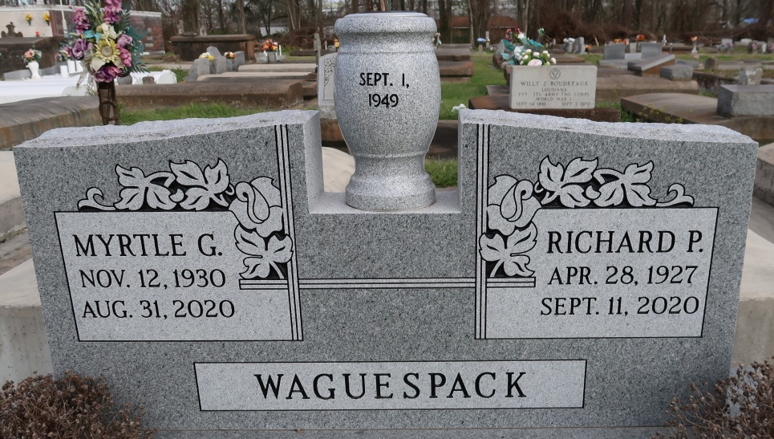

On August 31, 2020, Myrtle Gautreau Waguespack, 89, a long-time resident of Gonzales, passed away at her home surrounded by her loving family. She is survived by her husband of 71 years, Richard "ReRe" Waguespack. Together they created a home, often compared to Grand Central Station - where everyone was welcome and food was always on the table.
Myrtle is survived by 6 of her children: Adrian (Joann) Waguespack; Mike (Vicki) Waguespack: Rhonda (John) Gaughan; Bonnie (Randy) Simpson; George Waguespack; Kelli Waguespack, numerous grandchildren and great grandchildren. She is preceded in death by her son, Richard, Jr. "Woodie", her grandson, Brody Paul Johns, her parents Henry Wilton and Emma Gautreau and her two sisters Mildred, Margaret and sister-in-law, Carol. She is also survived by her brothers; Fr. Henry, Lou (Judy), Tommy (Linda) and Jerry (Laura.)
The viewing will be at Ourso Funeral Home September 3, 2020 from 9:00 to 11:00, and due to COVID-19 restrictions, masks are required. A funeral mass is limited to 100 people and will be at St. Theresa Church at 11:30 and the burial will follow at St. Mary's Cemetery in Union. In lieu of flowers donations can be made to Saint Jude Children's Hospital in Mrs. Waguespack's name.
The family would like to extend heartfelt gratitude to all of the staff at Louisiana Hospice and her caregivers who took such special care during this most difficult time. Ourso Funeral Home of Gonzales (www.oursofh.com) is in charge of arrangements.
The Advocate (Baton Rouge, LA)
Sep. 1 to Sep. 3, 2020

