Richard Paul Waguespack
April 28, 1927 – September 11, 2020

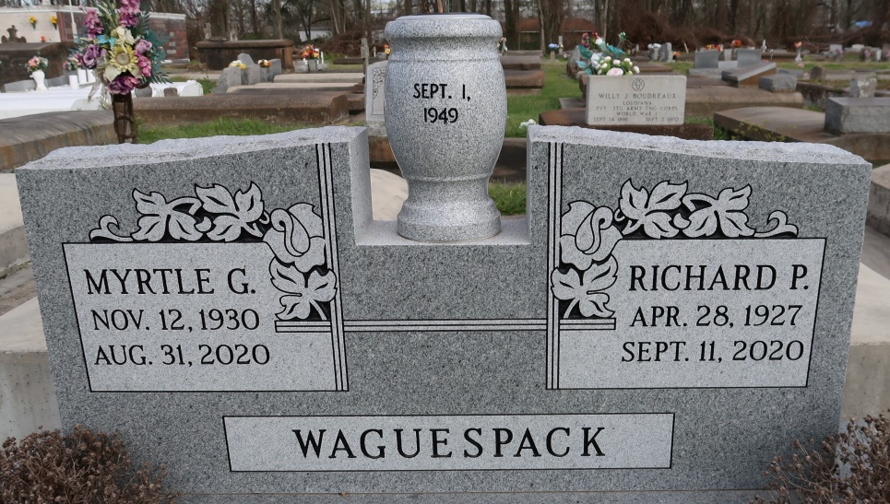

Richard Paul Waguespack, born on April 28, 1927, passed away at his home on September 11, 2020 surrounded by his loving family at the age of 93. He is preceded in death by his wife of 71 years, Myrtle Gautreau Waguespack, his son, Richard, Jr. "Woodie", his grandson, Brody Paul Johns, his parents George "Gee" and Pauline Waguespack, his brother Gerald and sister-in-law Sis.
ReRe is survived by 6 of his children: Adrian (Joann) Waguespack, Mike (Vicki) Waguespack, Rhonda (John) Gaughan, Bonnie (Randy) Simpson, George Waguespack and Kelli Waguespack, grandchildren; Country, Jade, Tobie, Joanie, Mandie, Tyler, Gee, Cody, Cade, Quinn, Korey, Nick, Emily, and Parker and numerous great grandchildren. He is also survived by his sister, George Ann (Hubble) Robert.
ReRe's life was centered around Granny, family & friends, and football & hunting season. He was the greatest PR man who never met a stranger, and loved welcoming them into his home.
The viewing will be at Ourso Funeral Home-Gonzales Wednesday, September 16, 2020 from 9:00 am to 11:00 am, due to COVID-19 restrictions, masks are required. A Funeral mass is limited to 100 people and will be at St. Theresa Church at 11:30 am and the burial will follow at St. Mary's Cemetery in Union.
In lieu of flowers donations can be made to Saint Jude's Children's Hospital in Mr. Waguespack's name. The family is extremely grateful for all of the staff at Louisiana Hospice and for his caregivers who loved and cared for him.
The Advocate (Baton Rouge, LA)
September 12, 2020

