Jason Jerome Williams
December 21, 1976 – July 9, 2021

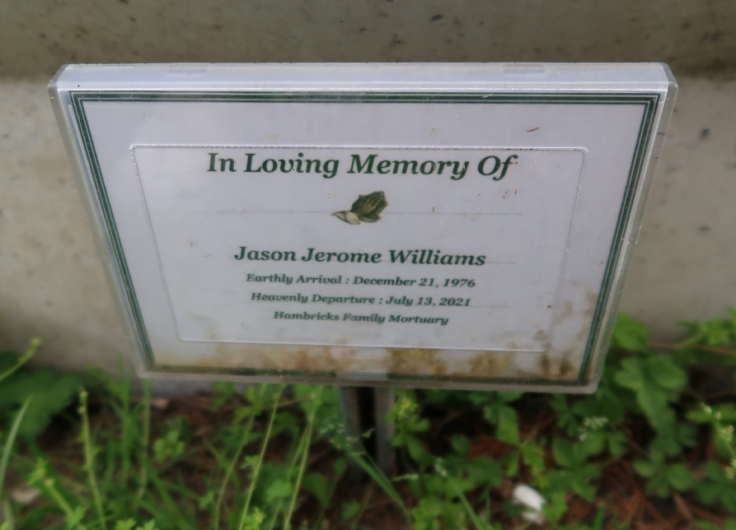

Jason J. Williams, a native of Convent, LA., passed away on Friday July 9, 2021 at the age of 44. He was a loving husband, father, and son. He was a family man who always puts everyones needs before his. He leaves to cherish his memories: his wife, children, mother and a host of family and friends. Visiting at St. John the Baptist Church, White Castle, LA,. on Saturday, July 17, 2021 from 9:30am until religious service time 11:30 am conducted by Rev. Gregory J. Coates. Interment in St. Mary Cemetery, Convent, LA. Hambricks Family Mortuary, Gonzales, LA., in charge of arrangements. www.hambrickmortuary.com.
The Advocate, Baton Rouge, Louisiana
Jul. 16 to Jul. 17, 2021.

