Jayme Jante Williams
May 9, 1988 – June 12, 2006

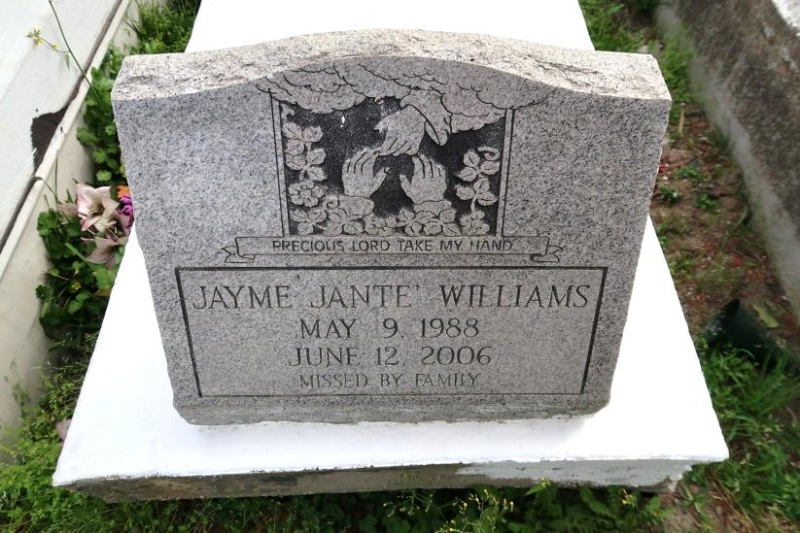

Jayme Jant'E Williams - A native and resident of Convent, she died Monday, June 12, 2006, at Our Lady of the Lake Regional Medical Center in Baton Rouge. She was 18 and a 2006 graduate of Lutcher High School. Interment in St. Mary's Catholic Church Cemetery, Convent.
She is survived by her mother, Robin Williams of Convent, father, Edward Lowery of Gauthier, Miss., grandfather, Issac and spouse Johnnie Mae Williams of Carville, six sisters, Jennifer and spouse Trevor Charles of Darrow, Jessica Williams of Convent, June and spouse Kuwan Striggs of Gonzales, Tasha Lowery of Gauthier, and Kim and Evangeline Lowery, both of Monroe, five brothers, Juan Williams of Convent, Jason and spouse Fabian Williams of Plaquemine, Darron Lowery of Columbus, Ohio, Damien Lowery of Atlanta, and Edward Williams of Dallas, a niece, Sanniya Johnson of Convent, three nephews, Ernest and J·Marcus Allen of Darrow and Jason Williams Jr. of Plaquemine, two aunts, Kimela W. Ward of Convent and Gail Frazier of Carville, and a host of aunts, uncles, cousins and friends.
Preceded in death by her maternal grandmother, Yvonne Delmore; great-grandmother, Albertine M. Delmore; great-grandfather, Lester Delmore; paternal grandparents, Patience Lowery and Sam Webb; two uncles, Robert and Kenneth Williams; and two aunts, Kimela and Tequilla Williams.
Gonzales Weekly Citizen (Ascension Parish, LA)
Wednesday, June 21, 2006
Contributed by Jane Edson

