Juanita (Benn) Youngblood
October 20, 1946 – October 12, 2016

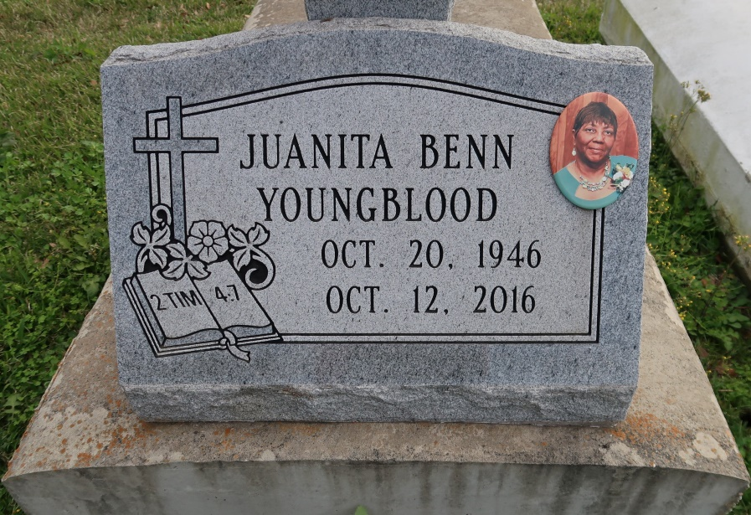

Juanita Benn Youngblood passed away at the age of 69. Visitation will be held on Saturday, Oct. 15 from 9 am until service at 10 am at St. James United Methodist Church in Convent. Interment will be at St. Mary's cemetery, Convent.
She is survived by three daughters, Tremeka Scott, Convent, Fallon Taylor, Baton Rouge and Kaneeka Taylor, San Antonio, TX; three sons, Vernon Youngblood, Convent, Ron Youngblood, Baton Rouge and Sean Youngblood, Convent; 4 brothers, 4 sisters, one half-sister, 14 grandchildren and 4 great grandchildren.
She was preceded in death by her parents, Andrew and Corinne Gaudin Benn; brothers, Kenneth Gregory Benn and Lyle Christopher Benn; and sister, Lynn Benn Landry. Lawson-Rollins funeral home in charge of arrangements.
The Advocate, Baton Rouge, Louisiana
Oct. 13 to Oct. 15, 2016.

