James “Noel” Adams Jr.
December 26, 1932 - October 14, 2017

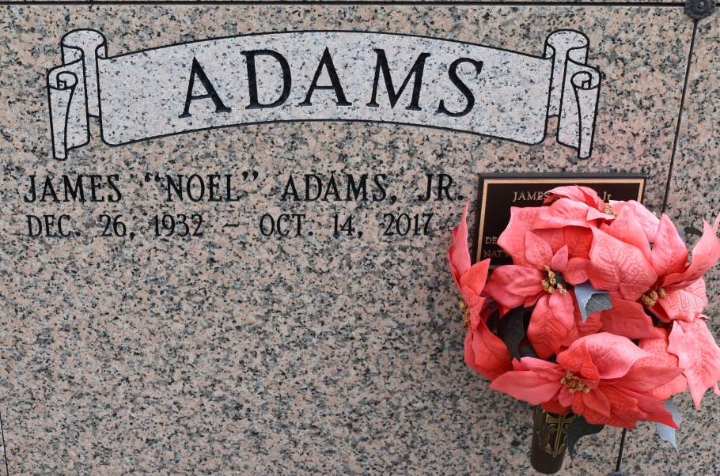

James "Noel" Adams Jr., a resident of Convent, LA., passed away on Saturday, October 14, 2017 at 9:10 p.m. at St. James Parish Hospital, Lutcher, LA at age 84. Noel, a US Army Veteran, Cypress Grove High School graduate, retired ICG Railroad employee of 40 years is survived by his wife of 62 years Victoria Ainey Adams, daughters Blanche Marie (Nashville, TN), Cheryl Diane (Convent), and Debra Ann (Prairieville). Grandchildren, G. Steven (Destrehan), James Anthony (Central) and Michael Leon (Haltom, TX), great granddaughter, Ariel (the love of his life) and sister Marjorie Adams. Preceded in death by his parents James Adams Sr. and Mildred Poche Adams, one brother Louis Adams and a sister, Theresa Adams Davis, father and mother-in-law Adam and Blanche D. Ainey Sr. Final resting at St. Michael Church Mausoleum, Convent, LA. on October 20, 2017.
The Advocate, Baton Rouge, Louisiana
Oct. 28 to Oct. 29, 2017

