Grayland Terry Allen
November 20, 1953 – April 13, 2020

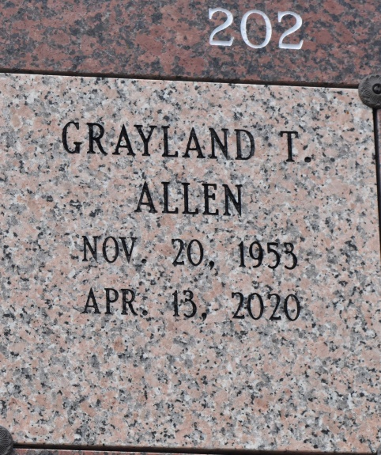
Grayland Terry Allen shed his earthly burdens and transitioned towards eternal peace and rest on Monday, April 13, 2020 at Our Lady of Lake in Baton Rouge, LA. All of our love and prayers could not persuade him to stay here. He chose to go and rest in the arms of his Heavenly Father.
Grayland affectionately known as “Gus” was born on November 20, 1953 to the late Wilbert Allen of Seattle, WA and Jewel Fields Allen of Gramercy, LA. Grayland was a devout Catholic. He was baptized at Sacred Heart in Gramercy, LA and a parishioner at St. Michael Catholic Church in Covent, LA. Grayland was joined in matrimony to Cathey Tureaud Allen and was a devoted husband of 45 years. They were connected at the hip, as “Gus” would say, and in return Cathey would respond, "we’re Siamese twins". They were each other’s everything with an unspeakable bond. To this union four children were born; Courtney Alexander Allen, Brandy Allen Foreman, Grayland Eric Allen and Danielle Marie Allen.
Grayland was a dedicated and retired employee of Colonial Sugar Refinery/Louis Dreyfus Company. He was employed with the company for 41 years before his retirement. During his employment he formed many bonds and acquired a host of friends including; the late Mose Brown, the late Roosevelt Armont, the late Harold Goff, the late Lawrence “Potty” Pittman, the late T. “Blacky” Adams, and the late Wade. Also, Karen Howard, Emmitt, George Weber, Sr., Leonard Morris and Poncho Grow.
The loving memories we have of Grayland “Gus” Allen will always be dear to our hearts. His memories will live on through his devoted wife, Cathey T. Allen; his loving mother, Jewel Allen; his sons Courtney Allen (Tiaa), Grayland Allen (Hope); daughters, LaTeka Manual, Brandy Foreman (Jeremey) and Danielle Allen(Polo). Grandsons; Tyrell, Courtney, Jr., Abry, Ethan, Jeremy, II, Grayson, Jeremiah, Hudson and Polo: granddaughters; Jabrielle, Kamryn, Kennedy, Micah and Zion: great-grandchildren; Trinity, Tyrell, Jr., Jori: brothers; Steven Allen, Mark Allen (Stephanie) and Troy Allen (Jesstina): sisters: Stephanie Smith, Deirdra Bradford
(Jerome) and Terrin Lee (Howard): brothers-in-law, Ralph Tureaud, Jr., Mark Tureaud (Marcia), and Ken Tureaud (Cynthia); sister-in-law, Kim Ware (Charles); his uncle, Wilmore Allen; aunts; Mable Pierre and Hazel Hudson, godchildren; Ricardo “Ricky Fields” and Leslie “Pookie” Robertson; 34 nieces and nephews, 50 great-nieces and nephews and 18 great-great-nieces & nephews and a host of cousins and friends: Ray “Jay” Jacobs, Isadore “Scab”Kirklin, Kermit “Bird” Michael, Charles “Pumpkinhead” Williams,
Ronald Michael, Cameron Burnett, Derick & Mark Schofield and his lifetime neighbors. Gus never met a stranger. Grayland was preceded in death by his father, Wilbert Allen; father-in-law, Ralph Tureaud, Sr.; mother-in-law, Marion Leblanc Tureaud; grandparents; Samuel Allen, Agnes Armont, Cecila Johnson & Ernest Fields; sister, Lenear Allen; brother, Stephone
“Patch” Allen; brothers-in-law, Robert “Bobby Tureaud & Eric Tureaud; uncles; Ernest “Tonk” Fields, Russel “Spook” Fields, Michael, William, Welmond, Whitney and Leon Allen; aunts; Violet Grace Largue and Bertha Allen Becnel; niece, LaNelle Melancon, great-niece, Sidricka Melancon, and great-nephew, Sidrian Melancon.

Treasures of Life Funeral Services
Gramercy, Louisiana

