Emile Augillard Jr.
January 26, 1941 – November 21, 2008

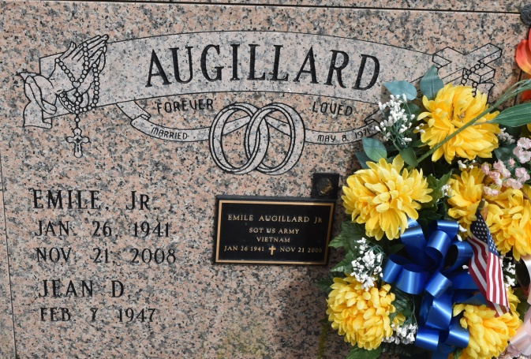
A native and resident of Convent, he died at his home on Friday, Nov. 21, 2008. He was 67. Visiting at St. Michael's Catholic Church, Convent, on Saturday, Nov. 29, from 9:30 a.m. until Mass of Christian Burial at 11 a.m. Entombment in the church mausoleum. Survived by his wife, Jean Dorsey Augillard, of Convent; two daughters and a son-in-law, Janeen and Joseph Benn and Shreese Dorsey; two sons and daughters-in-law, Emile III and Katrina and Christopher and Rhonda Green; three sisters and two brothers-in-law, Doris and Perry Gaudin, Shirley and Byron and Carolyn Augillard; brothers and sisters-in-law, Leonard and Joyce, Harvey and Connie, Herman and Sherelle, Michael and Hazel, Wayne and Alma, Darryl and Gail and Perry Augillard; sisters and brothers-in-law, Marlene Taylor, Renee Williams, Sandra Gilbert, Simon, Jerome and Norris Dorsey, and Cornelius, Donald and Mark Williams; mother-in-law, Sedonia Williams; seven grandchildren; an uncle, Robert Augillard Sr.; an aunt, Mary Augillard; nieces, nephews, cousins, other relatives and friends. Preceded in death by his parents, Emile Augillard Sr. and Cora Tureaud Augillard; a sister, Gloria Ann Augillard; and father-in-law, Simon Dorsey Sr. Arrangements by Brazier-Watson Funeral Home of Donaldsonville.

The Advocate, Baton Rouge, Louisiana
Nov. 28, 2008

