Gloria Ann Augillard
1952 – February 17, 2008

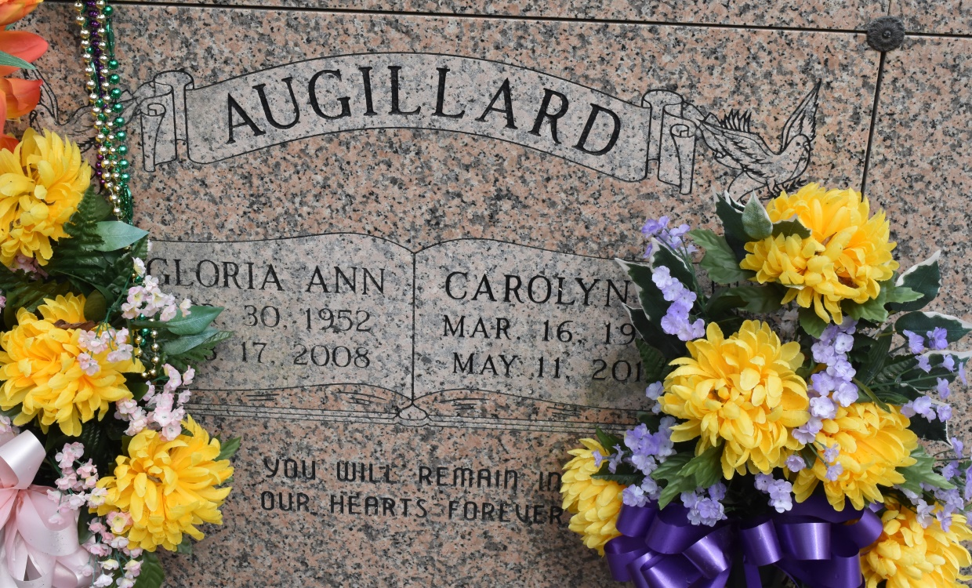
A native and resident of Convent, she died at 12:05 p.m. Sunday, Feb. 17, 2008, at her home. She was 55. Visiting at St. Michael's Catholic Church, Convent, on Saturday, Feb. 23, from 9:30 a.m. until Mass of Christian Burial at 11 a.m. Entombment in the church mausoleum. Survived by three sisters and a brother-in-law, Doris and Perry Gaudin and Shirley and Carolyn Augillard; eight brothers and their spouses, Emile Jr. and Jean, Leonard and Joyce, Michael and Hazel, Herman and Sheryl, and Wayne, Harvey, Darryl and Perry Augillard. Niece of Mary and Robert Augillard Sr. Also survived by numerous nieces, including Ashley Gaudin, nephews, cousins, other relatives and friends. Preceded in death by her parents, Emile Augillard Sr. and Cora Tureaud Augillard. Brazier-Watson Funeral Home, Donaldsonville, is in charge of arrangements.
The Advocate, Baton Rouge, Louisiana
Feb. 22, 2008

