Mary (Cortez) Becnel
October 17, 1941 - February 18, 2026

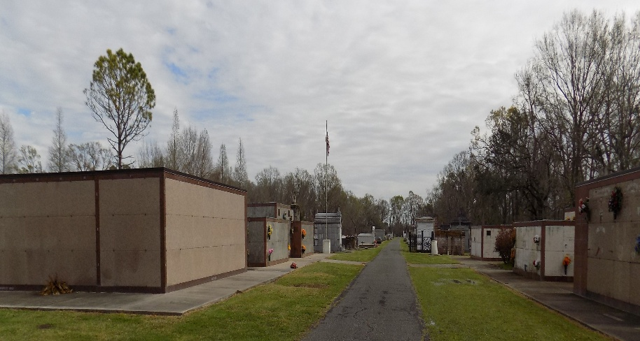

Mary Cortez Becnel, 84, passed away on February 18, 2026 at 12:15 pm. Born October 17, 1941, she was a native of Choctaw and resident of Convent, LA.
Family and friends are invited to attend a visitation on Saturday, February 28, 2026 at Saint Michael the Archangel Catholic Church in Convent, LA from 9:00 AM until service time. A Mass of Christian Burial will begin at 11:00 AM at church with burial in the church cemetery.
Mary is survived by his daughters, Michelle Lassere (Tracy), Danielle Louviere (Nelson), Nicole Ordoyne (Brian); grandchildren, Heidi, Traci (Dustin), Errol (Chelsi), Megan (Remy), Ronny, Andie; great grandchildren, Elliot, Brodie, Theo, Braxton, Emmet, Milo, Evie, Oliver, Eleanor; siblings, Emily Morvant (Mark); Rita Richard (Larry).
She is preceded in death by her husband, Errol Becnel; parents, Clay and Eva Cortez, Clay Cortez; sister, Audrey Porche (Tommy); brother, Leroy Cortez (Florence).
Online condolences can be made at http://www.ordoynefunerals.com/. Funeral arrangements were trusted to Ordoyne Funeral Home, 1489 Saint Patrick Street Thibodaux, LA 70301.

Ordoyne Funeral Home, Thibodaux, Louisiana

