Janet M. Benn
December 1, 1948 – October 27, 2010

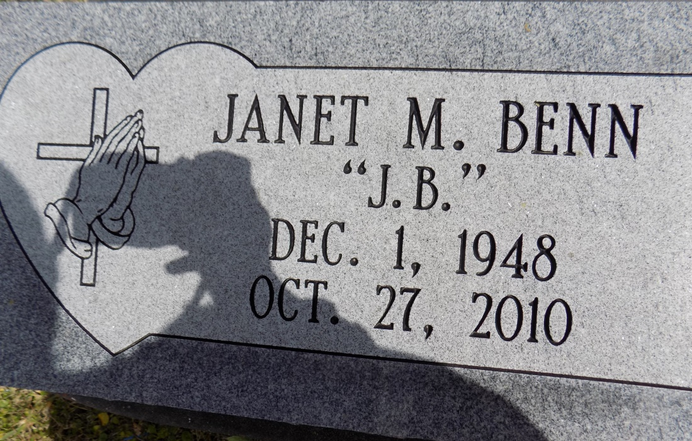
A native of Convent and resident of Gonzales, she died at Our Lady of the Lake Regional Medical Center at 11:28 a.m. Wednesday, Oct. 27, 2010. She was 61. Visiting will be at St. Michael's Catholic Church, La. 44, Convent, Saturday, Nov. 6, from 9 a.m. until Mass of Christian Burial at 10:30 a.m., celebrated by the Rev. Vincent Dufresne and Deacon Alfred Adams. Interment in the church cemetery.
She is survived by two sons and their spouses, Todd and Patricia Benn, and Eugene and Tynika Banks; her companion, Joseph Green Jr.; nine grandchildren, numerous nieces, nephews, cousins, other relatives and friends. She was preceded in death by her parents, Oliver Benn Jr. and Wilhemenia Jones Benn; a sister, Barbara Alexander; and a brother, Larry Benn. Arrangements by Brazier-Watson Funeral Home of Donaldsonville.
The Advocate, Baton Rouge, Louisiana
Nov. 5, 2010

