Don Patrick Bolding
August 17, 1970 - April 29, 2025

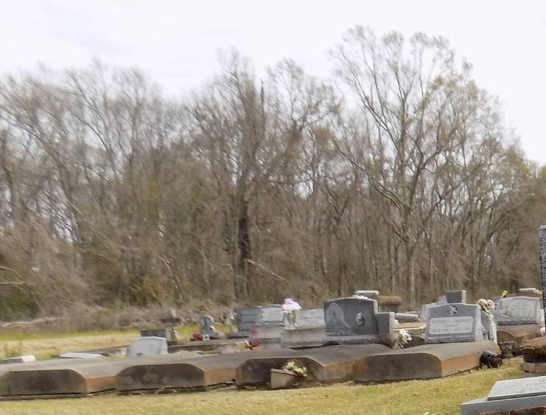

Laplace, LA - Don Patrick Bolding departed this life on Tuesday, April 29, 2025. Son of Beverly Ann Bolding and the late Bernard Jones. Husband of Wendy Boudreaux, Father of Darryn Sr., and Dylan (Daja) Boudreaux Sr. Grandfather of Dylan Jr., DyLah and Darryn Bolding Jr., Brother of Laronda, Kyelen Bolding, Kendra and Arielle Jones Ballansaw. Son-in-law of Anthony and Jancie Boudreaux Sr., Don is also survived by of aunts, uncles, nieces, nephews, relatives, and friends.
Funeral Service will be held on Friday, May 09, 2025, at 11:00a.m. at St. Michael Catholic Church Highway 44 Convent, La., Deacon Alfred Adams, Officiating. Interment in Church Cemetery. Visitation at 09:00 a.m. until funeral time.
Professional services entrusted to the caring staff of Hobson Brown Funeral Home, 134 Daisy St., Garyville, La. 70051, (985) 535-2516.

Nola.com
May 7, 2025

