Nestor Joseph Bourgeois
September 4, 1940 - September 3, 2025

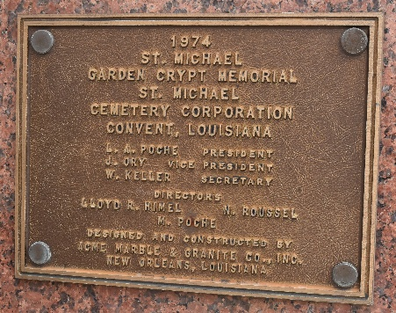

Nestor “NJ” Bourgeois, 84, entered into Eternal Life on September 3, 2025, with his loving wife by his side. Born in Convent, Louisiana, NJ lived a life rooted in love, faithfulness, humility, and gentleness.
A devoted Catholic, NJ was a man of quiet strength who lived by his values and served others with grace. He adored his family—especially the love of his life, Joyce—and cherished every moment spent with them. Though a simple man, his love ran deep, and he poured it wholeheartedly into those around him.
For over 55 years, NJ found joy and purpose working at Manresa House of Retreats, maintaining its beautiful grounds and buildings. He loved the outdoors, gardening, and sharing the fruits of his labor—quite literally—with his family. He also found joy in dancing, cheering on his LSU Tigers, going to the casino, and fundraising for his beloved church, St. Michael the Archangel. Though health challenges later limited his activities, he never lost his faith or spirit. He leaned on his family and trusted fully in the Lord and our Blessed Mother, enduring with strength, courage, and unwavering devotion. NJ’s legacy of kindness, humility, and wholehearted love lives on in the hearts of all who knew him. His radiant smile and gentle presence will never be forgotten.
He is survived by his beloved wife, Joyce Roper Bourgeois; his children, Lisa Medine (Scott), Jeff Bourgeois (Lesly), and Amy Adams (John); and his grandchildren, Trey Bourgeois (Rachel), Aaron Granier (Kassie), Kelsey Bourgeois, Jacob Granier (Jennifer), Madeline Medine, Sarah Brown (Perrin), Alaina Frierson (Hunter), Michael Bourgeois, Phillip Bourgeois, and Allie Adams. He was also blessed with 13 great-grandchildren, into whom he poured all of his love. NJ is also survived by his sister, Geraldine B. Hoover.
He was preceded in death by his parents, Nestor Bourgeois Sr., Claire B. Part, and Warren L. Part; his siblings, Willie Bourgeois and Jerry Bourgeois; his in-laws, Alfred and Stella Roper; and his son-in-law, David Granier.
Visitation will be held at St. Michael the Archangel Church in Convent, LA, on Saturday, September 6, 2025, from 8:30 to 11:15 a.m., with private family visitation from 8:00 to 8:30 a.m. A Catholic Mass of Christian Burial will be celebrated at 11:30 a.m. In lieu of flowers, donations may be made to the St. Michael the Archangel Rectory Fund.

Rose Lynn Funeral Home, Lutcher, Louisiana
September 12, 2025

