Stephen Francis Bourgeois
November 20, 1944 — January 30, 2024

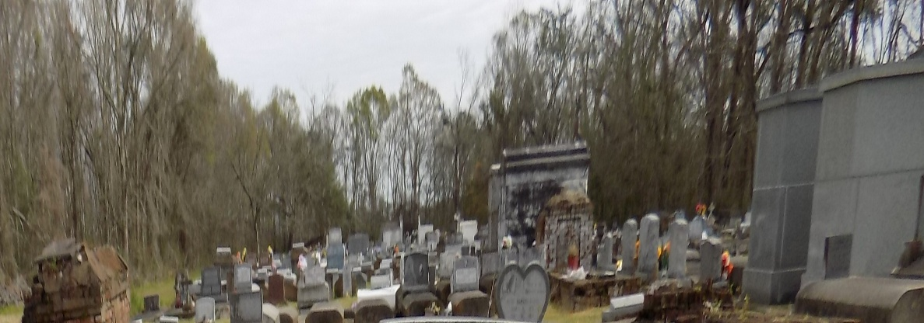

Stephen Francis “Be-Bop” Bourgeois, born in St. James on November 20, 1944, passed away on January 30, 2024, at the age of 79 in St. James parish. He was a member of the Vacherie Volunteer Fire Department. Be-Bop enjoyed spending his weekends at his favorite hangouts and dancing with family and friends. He worked for over 40 years in manufacturing. Be-Bop worked as a machinist for Zeringue’s Farm Equipment and Waguespack Welding.
He is survived by his sons, Drake Bourgeois and wife, Tricia and Ryan Bourgeois; grandchildren, Blake, Ainsley, Kelsey, Peyton, Braydin, Decatur; siblings, Barbara Webre and Tony Bourgeois.
Be-Bop is preceded in death by his wife, Gwen Poche Bourgeois; parents, Alcibiade Francis and Enda Tabor Bourgeois; siblings, Gloria Chaix, Leroy Bourgeois, Eric Bourgeois.
Visitation will be held at St. Philip Catholic Church in Vacherie, LA on Friday, February 9, 2024, from 9am until a memorial mass at 11am. Burial of the urn will take place at a later date at St. Michael the Archangel Catholic Church in Convent, LA.

Church Funeral Services & Crematory, Baton Rouge, Louisiana

