Shernette Alexander Carter
1981 – January 2, 1921

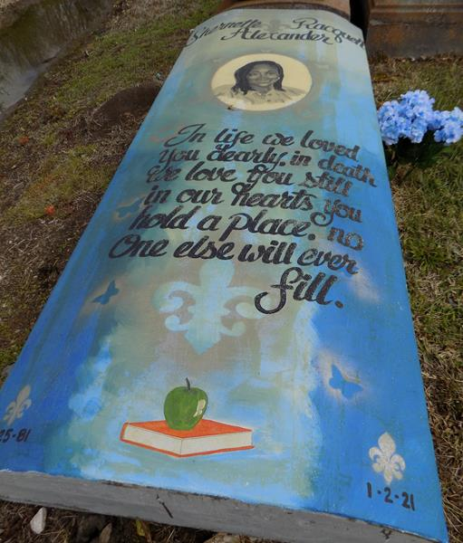

Shernette passed away peacefully at her residence in Gramercy, on Saturday, January 2, 2021. She was 39.
A Walk-thru Public Visitation will be held at the Funeral Home, 623 Railroad Avenue, Donaldsonville, on Monday, January 11, 2021 from 2-4 p.m. Visitation continues on Tuesday, January 12, 2021 at the funeral home from 10-10:45 a.m., followed by Private Limited Family Members Only funeral services, conducted by the Rev. Rowdy Kennard Scott, Pastor of King Solomon Baptist Church, Lutcher. Private graveside services in St. Michael's Catholic Cemetery in Convent. Masks Must Be Worn at All Times.
Survived by her husband, Jermaine Carter, Sr. Parents, Elvis Jackson, Sr. and Shelia Alexander Jackson. Daughters, D'Maiyah Alexander, Dakhyra Alexander and Je'Laina Carter. Son, Jermaine Carter, Jr. Sisters, Minnie Grady, Barbara Alexander, Monique, Tiffany, and Earline Howard, and Lashanda Jackson. Her brothers, Richard Grady, Jr., Quayshaun Alexander, and Darnell Howard. Her grandson, Bentley Alexander. Mother-in-law, Elaine Carter. Brothers-in-law, Kenneth Carter, Terri (Shari) Carter and Stacey (Shatrice) Beckett, nieces, nephews, cousins, other relatives and friends,.
Preceded in death by her brother, Elvis Jackson, Jr. and her father-in-law, Joseph Carter.
Brazier-Watson Funeral Home, Donaldsonville, Louisiana

**
Shernette Alexander Carter passed away peacefully at her residence in Gramercy, on Saturday, January 2, 2021. She was 39. A Walk-thru Public Visitation will be held at the Funeral Home, 623 Railroad Avenue, Donaldsonville, on Monday, January 11, 2021 from 2-4 p.m. Visitation continues on Tuesday, January 12, 2021 at the funeral home from 10-10:45 a.m., followed by Private Limited Family Members Only funeral services, conducted by the Rev. Rowdy Kennard Scott, Pastor of King Solomon Baptist Church, Lutcher. Private graveside services in St. Michael's Catholic Cemetery in Convent. Masks Must Be Worn at All Times.
Survived by her husband, Jermaine Carter, Sr. Parents, Elvis Jackson, Sr. and Shelia Alexander Jackson. Daughters, D'Maiyah Alexander, Dakhyra Alexander and Je'Laina Carter. Son, Jermaine Carter, Jr. Sisters, Minnie Grady, Barbara Alexander, Monique, Tiffany, and Earline Howard, and Lashanda Jackson. Her brothers, Richard Grady, Jr., Quayshaun Alexander, and Darnell Howard. Her grandson, Bentley Alexander. Mother-in-law, Elaine Carter. Brothers-in-law, Kenneth Carter, Terri (Shari) Carter and Stacey (Shatrice) Beckett, nieces, nephews, cousins, other relatives and friends. Preceded in death by her brother, Elvis Jackson, Jr. and her father-in-law, Joseph Carter.
Brazier-Watson Funeral Home in Charge of Arrangements.

The Advocate (Baton Rouge, LA)
Jan. 10 to Jan. 12, 2021

