Lionel Gabriel Chatelain Jr.
September 30, 1944 – February 19, 2024

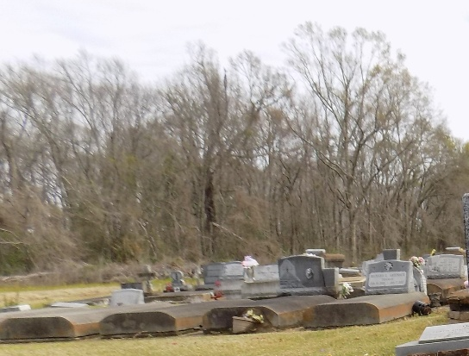

Lionel "L.G." Gabriel Chatelain, Jr., entered into eternal rest with his loving family by his side on Monday, February 19, 2024 at 3:18 PM. Age 79 years, he was a native of New Orleans, LA, a resident of Paulina, LA for 40 years, and a resident of Vacherie, LA for the past 7 months.
Beloved husband of Elaine Wehrlin Chatelain for the past 60 years. Loving father of Lizette C. Holt (Kevin), and Monique C. Montz (Doyle). Devoted grandfather of Laci Rose (Seth) and Nicholas Louque (Nicole). Great-grandfather of Owen Louque, Reece Louque, and Evelyn Rose. Son of the late Lionel and Pearl Desselles Chatelain. Brother of Catherine Lombard of Metairie, LA. He is also survived by a host of nieces, nephews, other relative and friends.
L.G. enjoyed spending time with his family and friends. His hobbies included woodworking and making rosaries. In his early years he enjoyed racing boats and in his later years he took pleasure in attending the boat races.
Relatives, friends of the family, officers and members of NOPBA and Local 198 are invited to attend the funeral Mass at St. Michael the Archangel Catholic Church, 6490 LA 44, Convent, LA on Saturday, February 24, 2024 at 10:00 AM. Visitation will begin at 8:00 AM until 10:00 AM at Church. Interment will follow at St. Michael’s Cemetery, Convent LA.

H.C. Alexander Funeral Home, Norco, Louisiana

