John Chmurka
November 24, 1919 – September 19, 2008

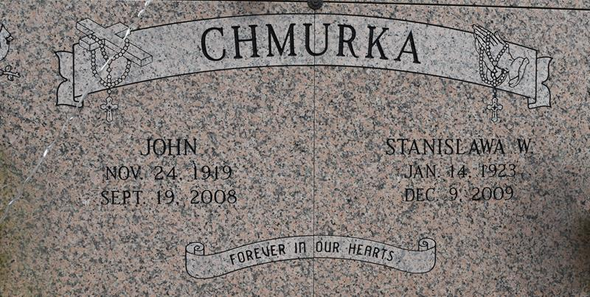

A retired employee of Pontchartrain Levee Board, he passed away Friday, Sept. 19, 2008 at 101!5 p.m. at D’Ville House Nursing Home. He was 88, a native of Poland, and a resident of Convent.
Visiting at St. Michael’s Catholic Church, Convent, on Monday, Sept. 22 from 8 a.m. until Mass of Christian Burial at 11 a.m., the Rev. Jason Palermo, celebrant. Entombment in the church mausoleum.
Survived by his wife, Stanislawa Wtorek Chmurka; three daughters and a son-in-law, Regina and James Falcon Sr. of Convent and Theresa Deiaune and Elizath Chmurka, both of Gonzales; two sons and a daughter-in-law, Edward Chmurka, of Prairieville, and Henry and Jane Chmurka of Gonzales; 11 grandchildren and spouses, James “Jamie” Falcon Jr. and fiancée Michelle, Jeffrey Falcon, Mack and Stephanie Delaune, Daniel and Jolie Delaune, Christopher Chmurka and fiancée Adrain, Benjamin and Susan Chmurka, Bryan and Ashley Chmurka, Michael and Erica Chmurka, John and Joseph Chmurka, Jennifer and Brad Andrews; and eight great-grandchildren, Aaron Delaune, Baylee Delaune, Kaitlyn Chmurka, Jacob, Taylor and Meghan Chmurka, Brady Andrews and Christian Chmurk. Preceded in death by his parents, a sister and a great-granddaughter, Katie Brooks Falcon.
Pallbearers will be Jamie Falcon, Jeffrey Falcon, Benjamin and Bryan Chmurka, Mack and Daniel Delaune, Christopher Chmurka and Michael Chmurka.
Special thanks to the D’Ville House nursing Home staff for their excellent care, compassion and prayers; and to the special angels at Life Source Hospice for such good care given and for their support and prayers during this difficult time.

The Advocate, Baton Rouge, Louisiana
Sunday, September 21, 2008
Contributed by Jane Edson

