Stanislawa (Wtorek) Chmurka
January 14, 1923 – December 9, 2009

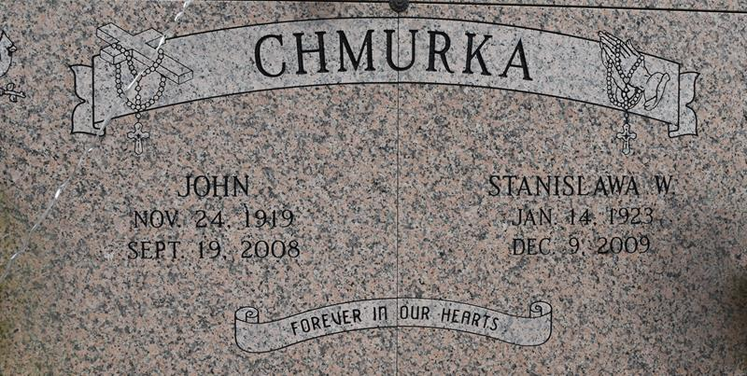

Stanislawa Or Stella Chmurka (Wtorek), 86
Stanislawa "Stella" Wtorek Chmurka passed away at D'Ville House Nursing Home Wednesday, Dec. 9, 2009, at 7:20 a.m. She was 86, a resident of Convent and a native of Poland. She was a former employee of Hymel's Seafood Restaurant for more than 25 years.
She is survived by three daughters and a son-in-law, Regina and James Falcon Sr., of Convent, and Theresa Delaune and Elizabeth Chmurka, both of Gonzales; two sons and a daughter-in-law, Edward Chmurka. of Prairieville, and Henry and Jane Chmurka, of Gonzales; 11 grandchildren and spouses, James "Jamie" Falcon Jr. and fiancée Michelle, Jeffrey Falcon, Mack and Stephanie Delaune, Daniel and Jolie Delaune, Jennifer and Brad Andrews, Christopher Chmurka, Benjamin and Susan Chmurka, Bryan and Ashley Chmurka, Michael and Erica Chmurka, John and Melissa Chmurka, Joseph Chmurka; and nine great-grandchildren, Aaron and Mack Trey Delaune, Christian Chmurka, Baylee Delaune, Kaitlyn Chmurka, Jacob, Taylor and Meghan Chmurka and Brady Andrews; and a brother, Joseph Wtorek. She was preceded in death by her husband, John Chmurka; her parents, Leon and Victoria Wtorek; and three sisters, Victoria, Maria and Janina; and a great-granddaughter, Katie Brooke Falcon. Pallbearers will be Jamie and Jeffrey Falcon, Mack and Daniel Delaune, Benjamin, Bryan, Michael, John and Joseph Chmurka and Christopher Chmurka. Special thanks to the D'Ville House Nursing Home staff for their excellent care, compassion and prayers and to Life Source Hospice for their good care, support and prayers.
Visitation will be held at St. Michael Catholic Church in Convent on Friday, Dec. 11, from 8 a.m. until Mass of Christian Burial at 11 a.m., with the Rev. Vincent Dufresne, celebrant. Entombment will follow in church mausoleum. Arrangements by Ourso Funeral Home in Donaldsonville. Leave online condolences at www.oursofuneralhome.com.
Advocate, The (Baton Rouge, LA)
Friday, December 11, 2009
Contributed by Jane Edson

