Edward Anthony Cola
November 3, 1942 – July 26, 2008

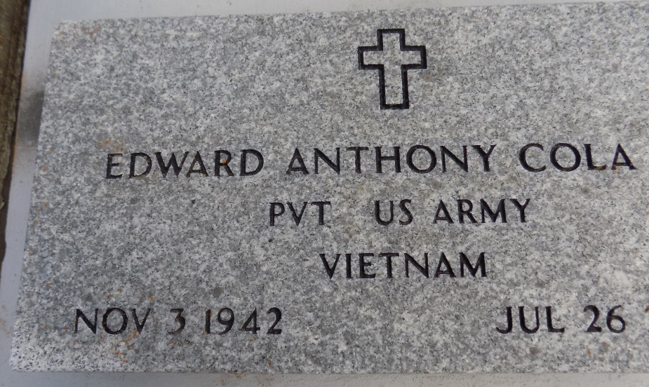
COLA Edward "Toney, Tex, Cowboy" Cola, Jr., Age 65, A United States Army Veteran departed this life on Saturday July 26, 2008 in Laplace, La., Son of The late Mildred and Edward Cola, Sr., Brother of Ann (Joseph) Green, Joann (Ernest,) Davis, Peggy Greene, Ophelia Williams, and Erroll J. Cola Sr., and the late Gary Cola, also survived by a host of aunts, uncles, nieces, nephew, 1 Sister in law Maryland Cola, other relatives and friends. A native of Kenner and resident of Lutcher, La.,
Memberd of St. Michael Catholic Church and all neighboring churches are invited to attend the funeral Service on Wednesday July 30, 2008 at 11:00 a.m. from the above named church Hwy 44 (River Road) Convent, La., Viewing on Tuesday from 5:30-7p.m. and at the church from 9a.m until Mass. Interment in St. Michael Catholic Church Cemetery, Convent, La Service Entrusted to Hobson Brown Funeral Home Garyville, La 985-535-2516
The Times-Picayune, New Orleans, Louisiana
Jul. 29, 2008

