Gary Martin Cola
April 22, 1958 – July 22, 2005

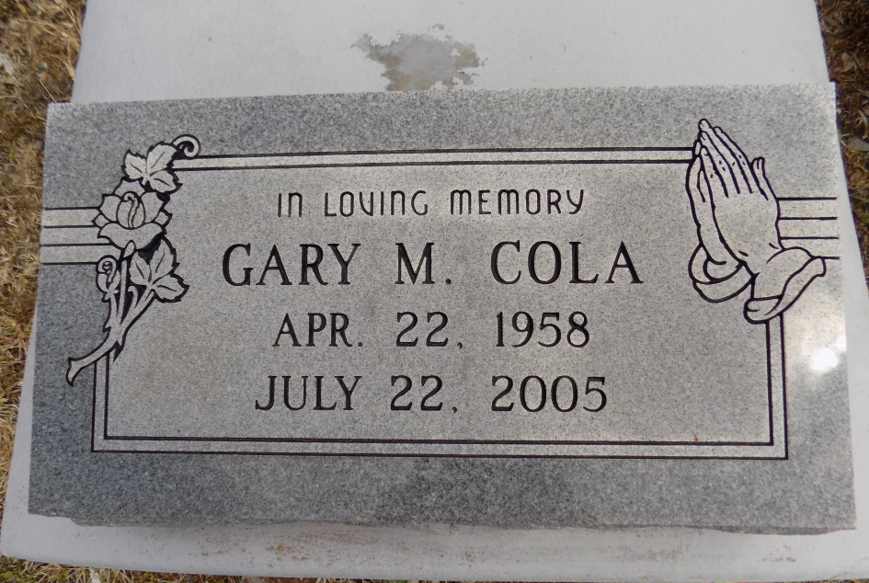
Cola, Gary Martin - A former employee with AJL Maintenance and a resident of Donaldsonville, he died Friday, July 22, 2005, at Prevost Memorial Hospital, Donaldsonville. He was 47 and a native of Convent. Visiting at St. Michael the Archangel Catholic Church, Convent, on Thursday, July 28, from 9 a.m. until Mass of Christian Burial at 11 a.m., conducted by the Rev. Edward Fuss. Recitation of the rosary at 10 a.m. Thursday. Interment in church cemetery.
He is survived by his wife, Maryland Y. Solete Cola; son, Gary Coleman of LaPlace; four sisters and two brothers-in-law, Ann and Joseph Green of Donaldsonville, Ophelia Williams of Kenner, and Peggy Greene and Jo Ann and Ernest Davis, all of Convent; two brothers, Edward A. Cola Jr. of Lutcher and Erroll J. Cola of Convent; two godchildren, Angel Ellis and Willie E. Davis; a grandchild; and a host of nieces, nephews, cousins, uncles, aunts, other relatives and friends. He was preceded in death by his parents, Edward Sr. and Mildred Jones Cola; a nephew and several aunts and uncles. Demby & Son Funeral Home, Donaldsonville, is in charge of arrangements.

The Advocate, Baton Rouge, Louisiana
Jul. 27, 2005

