Shirley Mae (Johnson) Cola
Unknown – February 11, 2024

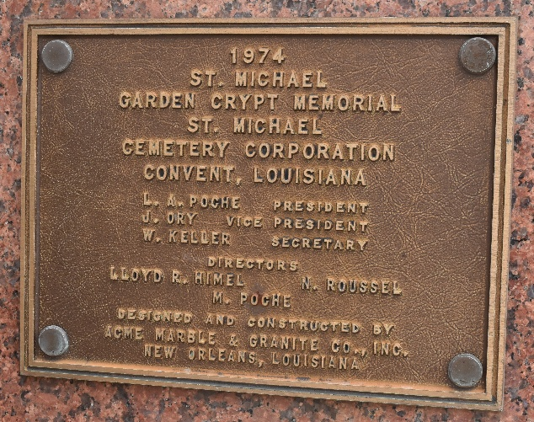

Shirley Mae Johnson-Cola departed this life on Sunday morning at 6:30 a.m. on February 11, 2024. She was united in Holy Matrimony to the late Joseph Junior Cola and to this union, one child, Anthony Ray Cola Sr. was born.
Shirley leaves to cherish her memories: her son, Anthony Ray Cola Sr. (Treva); two grandchildren, Ankaya Cola and Anthony Cola Jr.; siblings, Raymond Johnson (Rose) and Arthur Ray Johnson (Doris); and a host of nieces, nephews, other relatives and friends.
She was preceded in death by her parents, Julia Nicholas and Lawrence Johnson Sr.; her husband Joseph Junior Cola; sisters Geraldine Johnson and Ethel Johnson-Neyland; and brother, Lawrence Johnson Jr.
Relatives and friends of Shirley Cola are invited to attend a Celebration of Life on Saturday, March 2, 2024, at 10 a.m. First Community Antioch Baptist Church. 10860 Highway 3125, Lutcher, LA 70071. Visitation will be from 9 a.m. until service time. Interment: St. Michaels Cemetery in Convent, LA. Viewing will be held on Friday, March 1, 2024, from 3 p.m. to 6 p.m. at Bardell's Mortuary, 3856 LA 44, Mt. Airy, LA 70076.

The Advocate, Baton Rouge, Louisiana
Feb. 29 to Mar. 1, 2024

