Ernest Charles Davis Sr.
April 22, 1958 – July 22, 2005

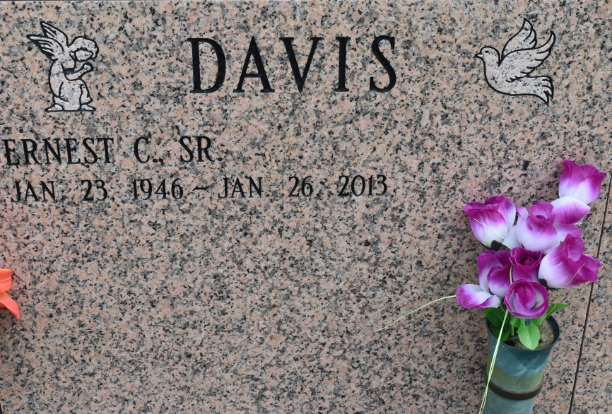
Ernest Charles Davis Sr., beloved husband of Joann Cola Davis, son of Lillie Mae Davis. He passed away on January 26, 2013 at Memorial Hermann Hospital in Houston, Texas at the age of 67. He is the father of Franshir Jackson, Mechell Brooks, Dawn and Bridget Davis, and Terrel and Ernest Davis, Jr. His brothers and sisters are Cleophies Page, Prince Davis, Michael and Don Davis, Ethel White, Betty Tircuit, and Rose and Mary Davis. Ernest is preceded in death by his father, Melvin Davis, Sr., one sister and two brothers. Visiting at Jeremiah Baptist Church, 3380 Hwy. 44, Darrow, La. Friday, Feb. 1, 2013 from 6:00 p.m. to 8:00 p.m.; Wake service at 8:00 p.m. On Saturday, Feb. 2, 2013, visiting from 8:00 a.m. to 10:00 a.m.; Funeral at 10:00 a.m. Interment at St. Michael's Mausoleum, Convent, La. Lawson-Rollins Purple Shield Funeral Home in charge. Please sign guest book at lrpsfh@eatel.net.
The Advocate, Baton Rouge, Louisiana
Jan. 30 to Feb. 2, 2013

