Audrey Marie (Schexnayder) Deslatte
April 9, 1929 - August 29, 2022

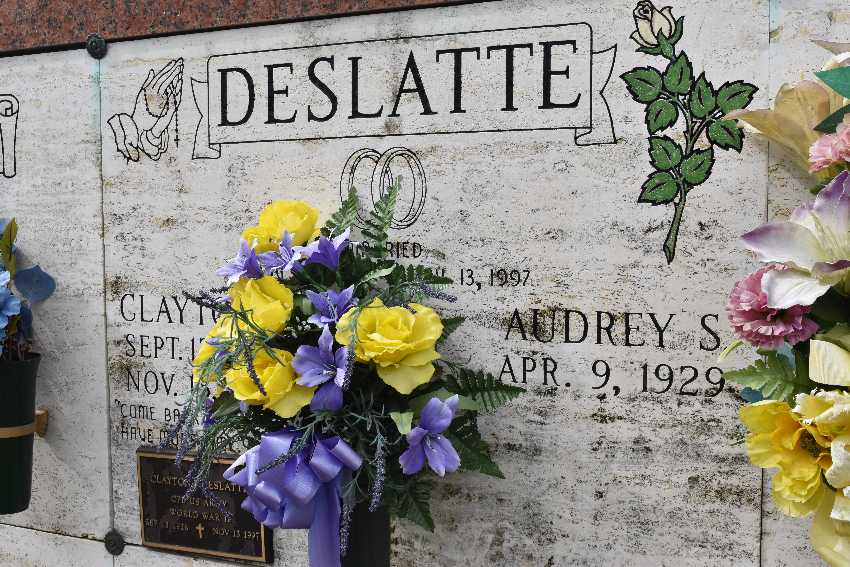

Audrey Marie Deslatte passed away on Monday, August 29, 2022 at the age of 93. She was a life-long resident of Hester, LA. Beloved wife of the late Clayton “Tiger” Deslatte. Loving mother of Clayton “Bubby” Deslatte, Lonnie Deslatte (Sharri), Danny Deslatte (Mona), Keith Deslatte (Belinda) the late Trudy St. Pierre and the infants Richard, Chris, and Mary Theresa Deslatte. Grandmother of Jessica Vicknair (Kevin), Jaclyn Blank (Roland “Rookie”), Torrie Deslatte (Marc), Michael Rote (Ryan), Maurice Deslatte, Jared Deslatte (Brianne), Jeffrey Deslatte (Kaleigh), Hollie Kelley (Scott), Jace Deslatte, Matthew Deslatte (Amanda), Megan Deloach (Brock), Dustin Deslatte, Paul Sliman, and Lindsay Smith (Jessica). Great grandmother of 22 and one on the way. Great-great grandmother of one. Godmother to Wilfred Schexnayder, Kent Louque, and Sally Lear. Daughter of the late Wilfred and Lelia Schexnayder. Sister of Janet Louque, the late Wilfred Schexnayder, Jr., Harry Schexnayder, and Margarite St. Pierre . Also survived by numerous nieces and nephews.
Audrey was a charter member and Regent for 14 years of St. Michael the Archangel Catholic Daughters #2080. She also served as President of St. Michael the Archangel Alter Society. She was an avid fan of LSU, Saints, and the Chicago Cubs.
The family would like to thank Juanita Scott and the staffs of St. James Parish Hospital and Chateau St. James for the care and compassion provided to Audrey.
Relatives and friends are invited to attend the Visitation and Funeral Mass at St. Michael the Archangel Catholic Church, 6476 LA- 44, Convent, LA on Friday, September 2, 2022. Visitation at church from 9:00 a.m. to 11:00 a.m. followed by a Funeral Mass at 11:00 a.m. Interment in St. Michael Church Cemetery, Convent, LA.
Arrangements by Rose Lynn Funeral Home. To view or sign the online guest book, please visit www.roselynnfuneralhome.com

Rose Lynn Funeral Home, Lutcher, Louisiana

