Alice (Minieville) Elfer
August 2, 1934 - February 12, 2026

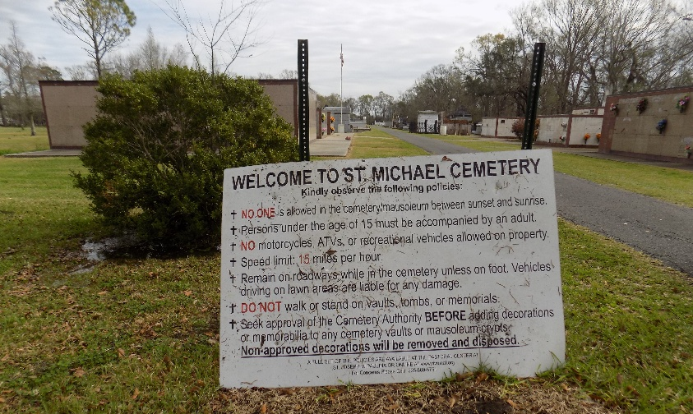

Alice Minvielle Elfer, peacefully passed away on February 12, 2026, at the age of 91. She was born on August 2, 1934, in Convent, Louisiana, and remained a lifelong resident there.
Alice enjoyed planting flowers in her garden, making rosaries, sewing, cooking, and above all spending time with family. She was known for always helping others, and loving people unconditionally.
Alice was the beloved wife of 70 years to Al Joseph Elfer, Sr.; loving mother to her children, Amy Pinson (the late Glenn), David Elfer (the late Dorna), the late Jan Elfer, Traci Louque (Leon), and Al Elfer, Jr.; grandmother of Paul Bourgeois (Courtney), Molly Pinson, Jamie Bourgeois (Lane), Jan Pinson, and the late Melissa Elfer; great-grandmother of Desiree Roddy, Hayden Elfer, Trey, Maci LeBlanc, Avah, Riley Bourgeois; as well as aunt to many nieces and nephews; daughter of the late Wilhemena Kilburn and Joseph Trist Minieville, Sr.
Relatives and friends are invited to attend a visitation and funeral mass at St. Michael Catholic Church, located at 6476 Hwy 44 Convent, La 70723, on Friday, February 27, 2026.

Rose Lynn Funeral Home, Lutcher, Louisiana
February 20, 2026

