Barry Paul Ellis Sr.

July 23, 1948 – February 8, 2021

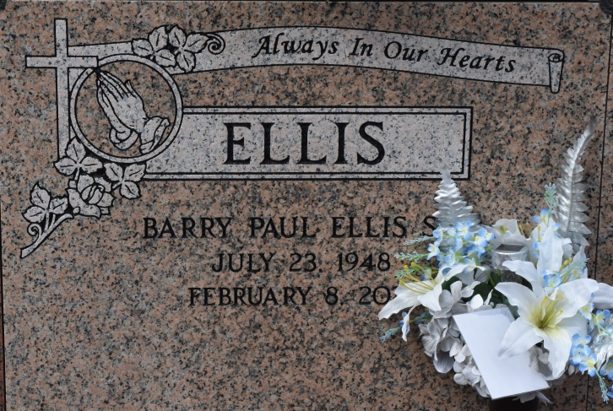

Barry Paul Ellis, Sr. a former constable for St. John the Baptist parish for 13 years departed this life on Monday, February 8, 2021 at the age of 72. Son of the late Nelson and Rose Ellis, beloved husband of 50 years to Barbara Wilson Ellis, father of Tinga (Leroy) Thompson, Barry P. Ellis Jr., Tina (Lamar) Roach, and Layman Taylor whom he reared as his on. Brother of Kenneth (Jennifer) Ellis, Norma Hailey, Norman Ellis, Steven (Karen) Ellis Sr., and the late Vernon Ellis. Barry is also survived by a host of grandchildren, nieces, nephews and a host of other relatives and friends.

Funeral Service will take place on Friday, February 12, 2021 at St. Michael Catholic Church 6476 Hwy 44 Convent, La, at 11: 00am.Visitation will be on Thursday February 11, 2021 at Hobson Brown Funeral Home 134 Daisy St. Garyville, La from 4-7 (ONLY). Interment in Church Cemetery St. Convent, La. Due to CDC (Covid19) restrictions seating is limited, mask and social distancing are required. Professional Services entrusted to the Caring Staff of Hobson Brown Funeral Home, 134 Daisy St., Garyville, La 70051, 985-535-2516.

The Times-Picayune, Baton Rouge, Louisiana

Feb. 10 to Feb. 12, 2021