Marie Emilie (Coycault) Gardere
December 12, 1857 – July 29, 1909

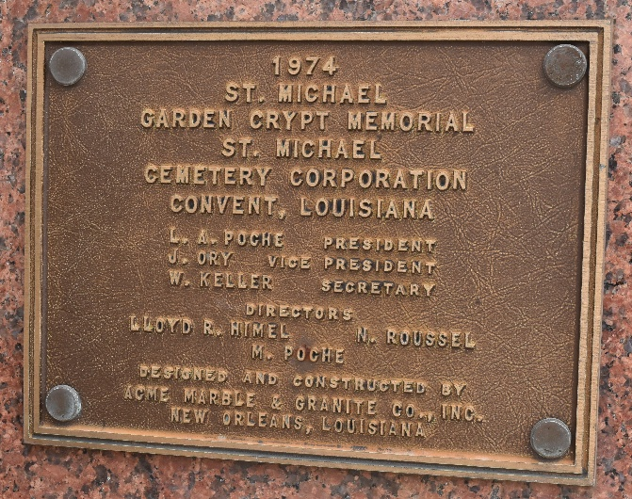

MOTHER GARDERE MOURNED

The remains of Mother Emily Gardere, who died at the Rosary Convent, on St. Charles Avenue, on Wednesday, were conveyed early yesterday morning to Convent, La., where the body of the deceased nun was interred in the cemetery of the order in St. Michael’s Parish.
Mother Gardere was born in Louisiana and entered the Order of the Sacred Heart about twenty years ago. She was a gifted musician and taught this branch in several convents of the order.
Previous to the removal of the remains a low mass was celebrated in the Convent chapel by Rev. Father Roby, S.J. This was said at 5 o’clock yesterday morning, after which the body was taken to Convent. The funeral services were simple and unostentatious and in keeping with the hidden religious life of the sainted nun. The office of the dead was recited on Wednesday night in the chapel, where the casket containing all that was mortal of the good nun was placed.

Times-Picayune, New Orleans, Louisiana
July 30, 1909

