Juliette (McLane) Garesche
December 21, 1826 – July 10, 1885

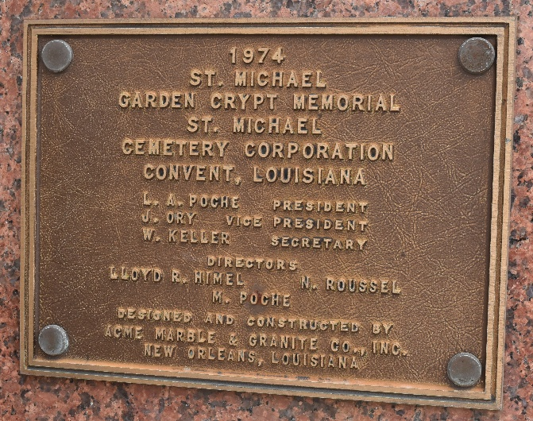

Juliette McLane was born in Wilmington, Delaware in 1826, the daughter of Louis McLane (1786-1857) and Catherine Mary Milligan. Louis McLane, whose handsome features can be found on old Treasury Notes, was successfully member of Congress, United States Senator, twice Minister to England, on the last occasion of which he had as his Secretary of Legation no less a personage than Washington Irvington; Secretary of the United States Treasury, 1831—1833; Secretary of State, 1833—1834, and president of the Baltimore and Ohio Railroad. Juliette is the granddaughter of Colonel Allen McLane, the valiant patriot of the Revolutionary War, immortalized in the oil painting by James Peale entitled: Rencontre between Colonel Allen McLane and Two British Horsemen.
The prospect of marriage with a Catholic gentleman of St Louis, Peter Bauduy Garesché, brought Juliette into contact with her future sisters-in-law who enlightened her concerning Roman Catholicism.
Juliette's parents were very much against the idea of their daughter becoming a Catholic and enlisted the aid of their local minister. As a consequence, one Sunday the minister preached a virulent anti-Catholic sermon, to which Juliette responded by standing, picking up her accoutrements and leaving the church. After this incident, Juliette's parents did not stand in her way!
Juliette was received into the Catholic Church in New York in 1846 by Archbishop John Joseph Hughes. Shortly afterward, Louis McLane was appointed United States Minister to England. While living in London, Juliette came to know and revere the Religious of the Sacred Heart and the work that the Society of the Sacred Heart was doing in England at that time.
Juliette married Mr. Garesché 25 SEP 1849 and the couple returned to Bauduy's home in St Louis, MO. The couple had four children, Katherine Milligan (known as "Kitty"), Lydia Johnston Stanislaus (known as "Lily"), John Peter and Virginia Margaret.
During the Civil War, Missouri was a boarder state with as many Northern as Southern sympathizers. The state therefore was vulnerable to attack from either side. Bauduy, having refused to take the oath of allegiance to the Union was forced to leave St Louis. As Inspector of the Powder Magazine at Columbia, SC, Bauduy served the Confederacy but law forbade any contact with the North. This meant that Bauduy's family seldom heard from him. When skirmishes ensued in and around St Louis, Bauduy's four children were sent to New York to live with Juliette McLane's sister. In 1863 Juliette obtained a pass to visit her husband and then journey to New York. She picked up the four children and made the dangerous journey back to South Carolina. Once in Columbia, Juliette devoted her days to nursing Confederate soldiers.
After the Civil War ended, the Garesché family moved back to St Louis. Bauduy died suddenly in 1868, and in rapid succession Juliette lost both John Peter and Virginia. After these deaths, Juliette decided to enter a convent. Juliette entered the Society of the Sacred Heart in Grand Coteau, LA, 5 MAY 1876. Previously two of her daughters, Katherine known as "Kitty" and Lily, entered the Society of the Sacred Heart. Juliette pronounced her vows in St Louis in 1878, with Bishop Ryan, a close family friend officiating and in the presence of her religious daughters. Juliette made her solemn profession at the Society's motherhouse in Paris in 1881, taking for her name in religion "Mother Bauduy McLane Garesché, RSCJ." Mother Garesché served the Society of the Sacred Heart in the United States and New Zealand, where she was sent with three other religious to start a school and convent in Timaru.
Mother Bauduy Garesché returned to St Louis and was appointed superior at the Academy of the Sacred Heart at 334 North Taylor known as "City House". When her health began to fail, Mother Garesché was sent to Louisiana in hopes that a warmer climate might be beneficial. She died at St Michael's, LA, in July of 1885.

Researched by Steven Keller using several sources, including The St Louis Catholic Historical Review, vol 2, no 1, January 1920 and The Garesché, De Bauduy and Des Chapelles Families by Dorothy Garesché Holland, 1963.

