Alan Maurice Gravois
August 5, 1961 - June 17, 2023

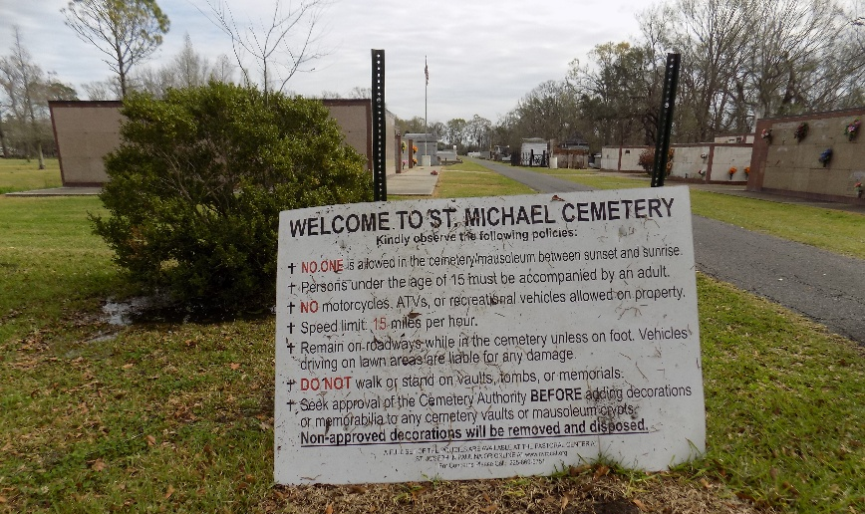

Alan Maurice Gravois, age 61, born on August 5,1961, passed away June 17, 2023. He was a resident of Hester, LA .
He is survived by his high school sweetheart, and beloved wife of 41 years, Lynette Poche Gravois; his children, Brandon (Devon), Bryan (Natalie), Alan, Jr. (Kylie) and Lacey (Jeff) Minor; grandchildren, Easton, Preston, Olivia, Myla, James, Jacob, Dawson, Kennedy, Cameron, Crue, Julia, and one on the way. His only perfect Godchild, Cassie (Jeremy) Catoire. His siblings, John (Gale), Marcelle (Roger) Blanchard, Mary (Michael) Roussel, Ozane (Darleen), Gerald (Mona), Vincent (Lydia), Clyde (Tania), Patrick (Wanda), Edward (Patti), Rose "Missy" Gravois, and numerous nieces and nephews.
He was preceded in death by his father, O.J. Gravois, Jr.; mother, Rosemary Becnel Gravois; brother, Michael James Gravois and his Parrian Tommy Keller.
He was a devout Catholic and attended weekly adoration. His passion was working in the fields on Welham along side his late father, brothers, sons, nephews, with grandchildren in training. His joys were sharing himself with anyone in the community.
Al will always be remembered as a kind, peaceful, loving husband, father and friend who enjoyed helping others. He also loved the simple life with family and friends, and was a stranger to no one. He immediately captured you with his smile and joy.
Visitation in his honor will be Wednesday at St. Michaels Catholic Church Hall in Convent, LA from 6:00 p.m. until 9:00 p.m.. A second visitation will be held Thursday, June 22nd, 2023 at St. Michael Catholic Church from 9:00 a.m. until The Mass of Christian Burial at 12:00 p.m. and the burial will follow in St. Michael Cemetery. In lieu of flowers, the family will accept offerings for St. Michael Catholic Church building fund.

Thibodaux Funeral Home, Inc., Lafourche Parish, Louisiana

