Deidrick Paul Green Jr.
Unknown - December 26, 2018

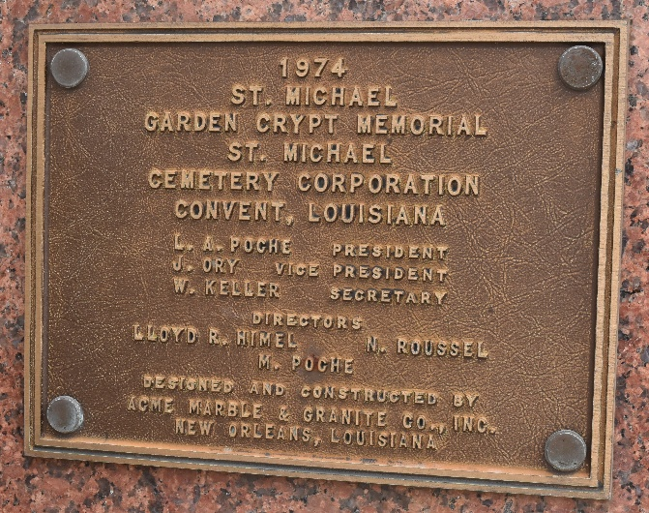

A NATIVE AND RESIDENT OF CONVENT. HE PASSED AWAY ON WEDNESDAY, DECEMBER 26, 2018 AT OUR LADY OF THE LAKE REGIONAL MEDICAL CENTER IN BATON ROUGE. HE WAS 23.
VISITING AT ST. MICHAEL'S CATHOLIC CHURCH, HIGHWAY 44, CONVENT, SATURDAY, JANUARY 5, 2019 FROM 10:00 A.M. UNTIL MASS OF CHRISTIAN BURIAL AT 11:00 A.M., REV. VINCENT DUFRESNE, PASTOR, DEACON ALFRED ADAMS, OFFICIATING. INTERMENT IN CHURCH CEMETERY.
SURVIVED BY HIS MOTHER, DENESSA COLA LEWIS. HIS FATHER, DEIDRICK GREEN, SR. HIS DAUGHTER: AUBREE GREEN. HIS SISTERS: TA'SHARI COLA, KE'RASHAWN (RONALD) BOUDREAUX, AND BREION AND DEION GREEN. HIS MATERNAL GRANDFATHER, ANDREW COLA, SR. HIS PATERNAL GRANDFATHER, ARTHUR (GERALDINE) WASHINGTON, JR. ALSO NUMEROUS AUNTS, UNCLES, NIECES, NEPHEWS, COUSINS, OTHER RELATIVES AND FRIENDS.
PRECEDED IN DEATH BY HIS MATERNAL GRANDMOTHER, MARVA DEAN SHORTY AND PATERNAL GRANDMOTHER, PHYLLIS GREEN.
BRAZIER-WATSON FUNERAL HOME, DONALDSONVILLE, LOUISIANA

