Glynn Griffin
March 17,1951 – December 2, 2024

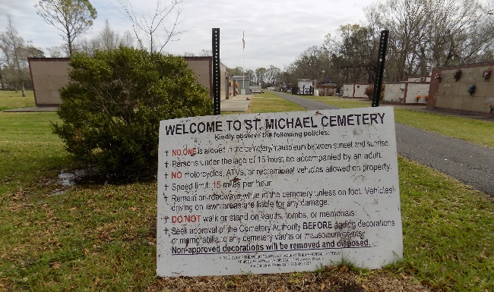
Glynn Griffin, affectionately known as "Red," passed away on Monday, December 2,2024 at the age of 73. He was born on March 17, 1951, to the late Robert Griffin, Sr., and Leona LeBoeuf-Griffin. He was a native of Greensburg, Kentucky and a resident of Reserve, LA.
Glynn is survived by his two brothers, Van (Kay) and Christopher Griffin, nephews Copeland and Jamaal (Tyra) Griffin, Akeem Albert, Christopher Snyder, and Alisha Snyder Christion (Towaski), Aunt Geraldine Jacques LeBoeuf and his devoted first cousin, Whitney Joseph, Jr.
He was preceded in death by his parents, the late Robert Griffin, Sr., and Leona LeBoeuf-Griffin, as well as his beloved brothers, Randal D. Griffin and Robert (Ruby) Griffin, Jr. He also leaves behind a host of nieces, nephews, cousins, and friends who will cherish his memory.
Relatives and friends of the family, Priest and Parishioners of St. Joan of Arc Catholic Church and Our Lady of Grace Catholic Church are invited to a Mass of Christian burial 11:00am on Friday, December 13, 2024, at St. Joan of Arc Catholic Church, 529 West Fifth Street, Laplace, LA. Visitation 9:00am until time of mass. Interment St. Michael the Archangel Catholic Church Cemetery, 6484 LA-44, Convent, LA 70723. Recitation of the most holy rosary 10:15am.

Patrick H. Sanders Funeral Home & Funeral Directors, LLC., Laplace, LA
Dec. 9, 2024

