Rev. George Guidery

December 23, 1940 – December 9, 2019

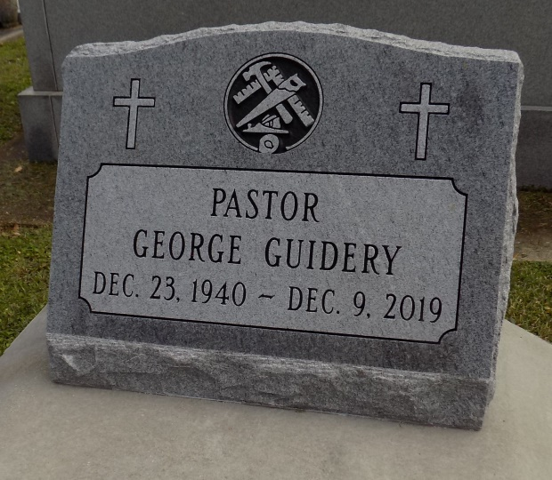

Rev. George Guidery, the Pastor of KFS Ministries passed away peacefully with family on Monday, December 9, 2019 at the age of 78. Rev. Guidery was born on December 23, 1940 to the late Pastor Lester and Mary Guidery. In 1942 the family moved to New Orleans, Louisiana. Pastor George Guidery attended Carter G. Woodson, McDonogh# 35 Senior High School and later received his bachelor's degree from Southern University of New Orleans and a Master's plus 30 from Louisiana State University. Rev. Guidery is a retired school teacher who served over 30 plus years in both, Jefferson and Orleans Parish school systems. He served as a pastor for over 30 years.

He is survived by two daughters, Ingrid Myers and La'Christian Guidery, one granddaughter Dejanique Myers Maye (Clyde Maye III), one sister Anna Mae Guidery, one brother-in-law Lionel West and a host of nieces, nephews, and cousins. Rev. George Guidery was the former husband of Barbara Jean Guidery.

Relatives and friends of the family, also members of KFS Ministries and the many lives that Pastor Guidery has touched are invited to Celebrate the legacy and life of the undershepard at First House of Prayer Baptist Church 2826 LaSalle Street New Orleans, Louisiana 70115 on Saturday, December 21, 2019. Visitation will be held at 9:00 a.m. until 10:00 a.m. along with a musical tribute. Funeral Services beginning at 10:00 a.m. Interment will immediately follow at St. Michael the Archangel Cemetery 6484 LA-44, Convent, Louisiana 70723. Arrangements Entrusted To Estelle J. Wilson Funeral Home, Inc., 2715 Danneel Street, N.O., LA. 70113. Information (504) 895-4903. To sign online guest book please visit [www.legacy.com.](http://www.legacy.com/)

The Times-Picayune, New Orleans, Louisiana

Dec. 18 to Dec. 21, 2019.