Katherine Frances (Part) Husser

November 19, 1946 – August 23, 2020

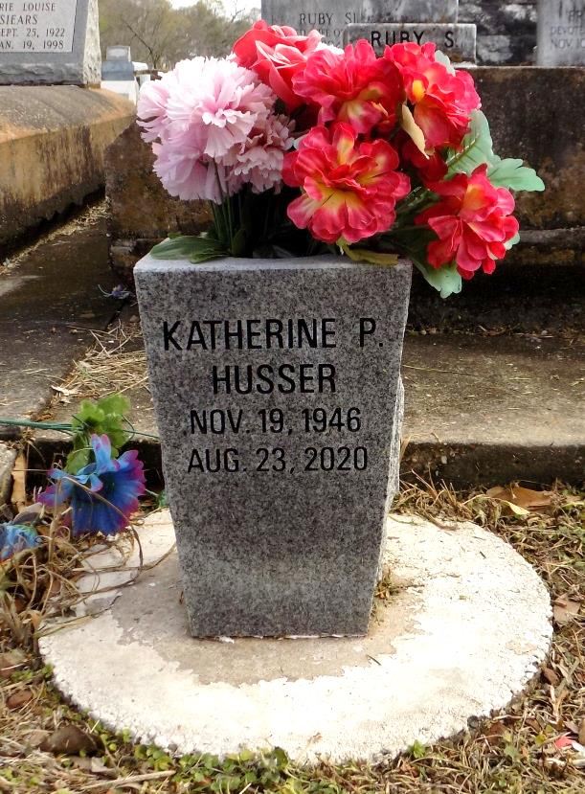

Katherine Frances Husser passed away due to cancer on August 23, 2020. Age 73, a native of Gramercy and a resident of Kenner for over 40 years. Beloved wife of Horace C Husser, Jr. for 38 years. Mother of Bryan (Donna) and Scott Boudreaux. Grandmother of Nicholas, Zachary and Justin Boudreaux, Scott Jr, Andrew, Isabella and Olivia Boudreaux. Daughter of the late Francis Lloyd Part and Ruby Simon Part. Sister of Jeanne Hyde (James), Denise Schayot (Will) and the late Adele Portera and Susanne Weick. Daughter-in-law of Dorothy Husser and the late Horace Husser, Sr. Also survived by nieces and nephews. Katherine worked for Denny's on Williams Boulevard for 13 years and was a graduate of Fortier High School.

Neptune Society

Kenner, Louisiana