James Randal Hyde

December 15, 1968 – July 6, 2015

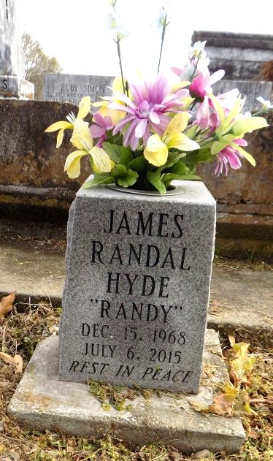

James Randal (Randy) Hyde passed away Monday July 6th, 2015 at the age of 46 due to complications from a sudden illness. He was a lifelong resident of Kenner, LA. He is survived by his wife Angela Cavallino Hyde, daughter Jessica, son Bobby and grandson Parker. Beloved son of James and Jeanne Hyde, sister Stephanie Catalano, brother in law Frank and nephew Tyler, sister Jennifer Hymel and -nieces Kody and Karmine. Sister in law Crissy Locatta Suzie Cavallino, brother in law Dominick Locatta and the late daryl Cavallino. Also survived by many loving Aunts, Uncles, cousins and friends.

At the time of his death he resided with his parents. He was a roofer for many years, but in the last years he was disabled from a serious car accident in 1997. He will be sadly missed by his family and friends.

Relatives and friends are invited to attend services at St. Jerome Catholic Church. 2402 33rd St. Kenner, LA on Thursday, July 16. 2015 at 2:00 PM. Visitation immediately following in the parish hall. NEPTUNE SOCIETY OF NEW ORLEANS is in charge of arrangements. To sign the guestbook, visit [www.theadvocate.com.](http://www.theadvocate.com/)

The New Orleans Advocate, Louisiana

Jul. 11 to Jul. 16, 2015