Cynthia (Jacque) Irvin

January 20, 1946 – December 28, 2015

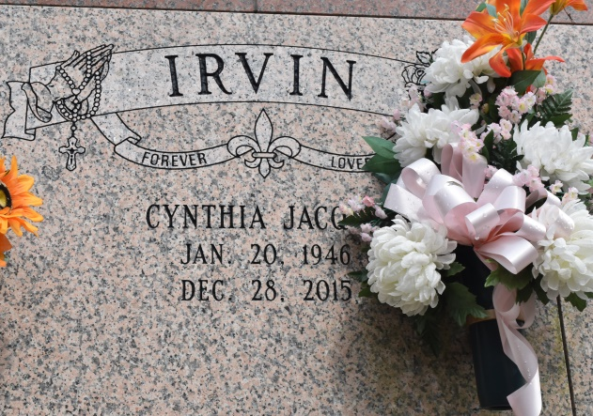

Cynthia Jacque Irvin, 69, a resident of Gonzales, LA and a native of Convent, LA, passed away on Monday, December 28, 2015 to eternal rest. She was a retired school teacher of the St. James Parish School Board System.

Visitation will be held Saturday, January 2, 2016 at St. Michael Catholic Church, 6484 Highway 44, Convent, LA from 9:30 am – 11:00 am. Followed by religious service at 11:00 am conducted by Father Alex Sheldon. Burial will follow in the St. Michael Cemetery.

She is survived by son Mario (Nicholl) Irvin, brother Jewel Jacque, niece Teka (Cornell) Steptore-Smith, great nephew Colin Neal Smith, great niece Avery Alexandra Smith, godchildren Danitria (Johnny) Norman and Kori Jones along with a host of brothers and sisters in-law, nieces, nephews, cousins and friends. She was preceded in death by husband Burnell Irvin, parents Earl and Veronica Jacque Sr., brother Earl Jacque Jr., sister Elaine Jacque and nephew Corey Steptore. Lawson-Rollins Purple Shield Funeral Home, 511 W. Tobey Ave., Gonzales, LA in charge of arrangements.

The Advocate, Baton Rouge, Louisiana

Dec. 30, 2015 to Jan. 2, 2016