Truman Manuel Jacques

November 5, 1936 – February 4, 2021

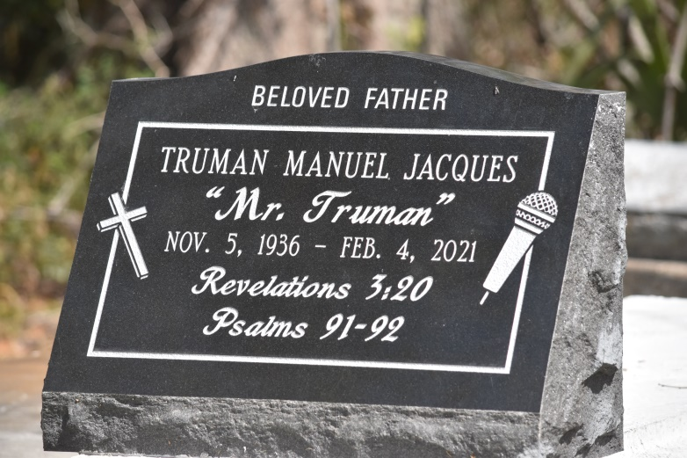

Truman Manuel Jacques was born in Convent, Louisiana. He was raised by his mother Elsie Stewart, a woman he would later honor as the most remarkable people in the world in a 1978 LA Times article entitled My Mother the Philopsopher, Diplomat and... Brought up with the challenges of inequality and segregated school systems, Truman often would be heard speaking about his earliest childhood memories living in Louisiana's most rural communities. He attended Cypress Grove High School in Lutcher, LA, where he maintained straight A's throughout high school. After realizing there were so few options to advance his professional career goal, and escape generational poverty, Truman made a decision to join the Air Force in 1956. During this time, he took courses in night school and earned his AA degree from Los Angeles Community College. He was on the right path, as this would be his sure ticket to higher education and a better quality of life.

After returning from Europe and obtaining his military discharge during the height of the civil rights movement, Truman was selected into service in what then called "the domestic peace corps," an action arm of the war on poverty devised by the late President Lyndon Johnson. This enabled his opportunity to attend the University of California Berkeley, where only 100 students were selected to participate in a program focusing on inner-city poverty and strategies to break generational poverty and unfair distribution of resources. At UC Berkley, Truman assigned to identify of institutional racism and its effects on poverty in the inner city. The "laboratory" was the streets of Oakland. However, upon completion the intensive training, each group member was assigned to a specific inner city government body and given a mandate to break the cycle.

After successful completion, Truman was sent by the California State Government to South Central Los Angeles (Compton and Watts) to devise, plan and implement projects to improve the conditions for individuals including motivation, jobs, small businesses, education and training opportunities. Through several years and a major riot, Truman implemented programs and fought to bring a measure of hope and change to the residents. Leaving Berkley shortly after the "Hunters Point Riot", Truman's first assignment was Compton, CA and his second was Watts, CA. Truman remained on the Watts assignment for three years, becoming instrumental in the application of almost every solution to the poverty cycle during that time. The areas of reported impact included education, housing, jobs, attitudinal restructuring, and the use of media. Truman is a Magna Cum Laude graduate from Pepperdine University with a Bachelor's Degree in Communications, and he completed his Master's Degree in the field of Public Communications maintaining a 4.0 average.

Shortly after the riot of 1965, Truman was discovered by CBS Television and he became a Television Host and Producer for the next 25 years, hosting the longest running TV show of his career, Today's Religion. After retiring from CBS, he worked for the rival network ABC, where he hosted and produced radio call-in programs for several years. In 1990, after his media career, Truman served the City of Inglewood as Communications Director with the primary goals of upgrading the City's image and its communications with the residents. There he published the City's Newspaper, determined the nature of Hollywood movies allowed to be filmed within the city, supervised the Public Relations staff and worked on the City's public image for five years. During those years, he planned and directed the activities of "Martin Luther King's Day," "Welcome Home Desert Storm," the annual "Community Unity" day and other major events of the City. For more than a quarter of a century, he conceived and hosted over 2,000 programs on every conceivable subject. He interviewed prominent people of the era, including political, religious, entertainment, and sports figures such as Muhammad Ali whom he credits for putting him on the map by granting an interview during his early career. He lectured extensively, served as Emcee for hundreds of occasions, tutored in public speaking and "ghost-wrote" speeches for public officials. Truman appeared in cameo roles as a reporter in several movies, the most notable being Rocky II. Truman was twice nominated for the prestigious Emmy Award, and received many commendations from federal, state, and local governments, and business and civic organizations. These included NAACP, Urban League Man of the Year, National Organization of Negro Women, SCLC, and countless others. After retirement, he returned to his hometown of Convent, Louisiana, where he constructed a studio on his premises to find local talent and where people could come to record stories and poetry, and even perform some nights when he hosted his juke joint style open mic. Truman was instrumental in organizing "Cypress Grove Whole School Reunion and Parade" reuniting hundreds of graduates from all years and from all over the United States. In 1969, Cypress Grove School was renamed. To ensure the grounds would forever be remembered as Cypress Grove, Truman and the Reunion Committee installed and dedicated a plaque.

At his home, he spent time converting more than 400 of his religious programs from video tape to DVD, studied the bible, and produced his own motivational literature and tapes. Later, he expanded the studio's scope to produce family history CDs that allowed people to preserve their family memories. Truman was a member of the "Brothers Club," a social and philanthropic organization based in Convent that is more than 35 years old. Truman's best friends and Cypress Grove classmates (Floyd, Milton, Ralph, Richard and Thaddeus) will truly miss the weekly conference calls that Truman initiated.

Truman is survived by his children Renee, Pam and Andre, and also his grandchildren Briauna, Stone, Lise, Truman, and Louise. Truman's surviving brothers are Larry and Gregory.

Funeral Service will take place on Monday, February 15, 2021 at Hobson Brown Funeral Home 134 Daisy St., Garyville, La, at 11: 00am.Visitation 9am until funeral time (ONLY). Interment in Cemetery Luther, La. Due to CDC (Covid19) restrictions seating is limited, mask and social distancing are required. Professional Services entrusted to the Caring Staff of Hobson Brown Funeral Home, 134 Daisy St., Garyville, La 70051, 985-535-2516.

The Times-Picayune, New Orleans, Louisiana

Feb. 13 to Feb. 15, 2021