Marie (Puccio) Keller
Abt. 1940 – September 22, 2025

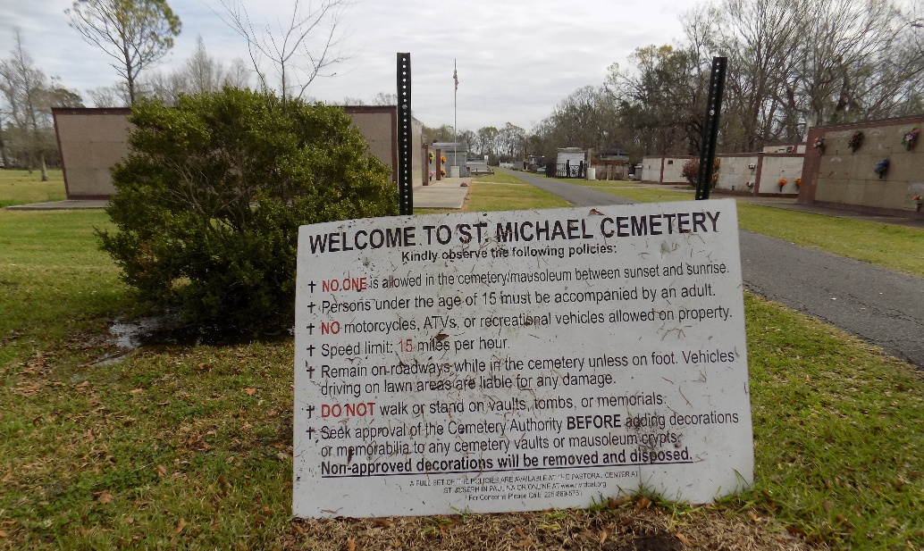

Marie passed away peacefully at her loving daughter's home, Mary Grace Keller, on September 22, 2025, at the age of 85. She was born in New Orleans, LA and a resident of Convent, LA until 2020.
In 2020 Marie became a resident of Gulf Breeze, FL living with her daughter/caregiver, Mary Grace. She was a wonderful mother who was always there when we needed her the most, offering support, wisdom, and love in abundance. A friend to many, she was a cherished member of the community in Convent, leaving behind a legacy of kindness and strength. She was a member of St. Michael's Catholic Church Ladies Alter Society, Catholic Daughters of America, St. Mary's and St. Michael's Choir.
Beloved wife of the late Paul Karl Keller. Loving mother to Oren Keller (Heather), Angela Keller Macias (Gerry), and Mary Grace Keller, as well as having 4 grandchildren. Daughter of the late Nelva Puccio LeBlanc and Sam Puccio, Sr., stepfather Joseph LeBlanc, sister the late Betty Brignac and Percy, brother late Sam Puccio Jr. and survived by Della Puccio. Survived by many nieces and nephews.
Marie will be forever missed, never forgotten. My dear mother whose strength, grace, and love remain an everlasting source of inspiration. Forever grateful for the time shared together. Remembering a remarkable woman, mother, wife whose laughter and love brightened every day.
Rest In Peace, Mom.
A private mass will be held at St. Ann Catholic Church in Gulf Breeze, Florida. Her ashes will be brought to St. Michael Church Cemetery in Convent, Louisiana.

Legacy.com by Family-Funeral & Cremation – Pensacola, Florida
Oct. 27, 2025

