Danielle (Harper) Lewis

September 21, 19-- - March 23, 2012

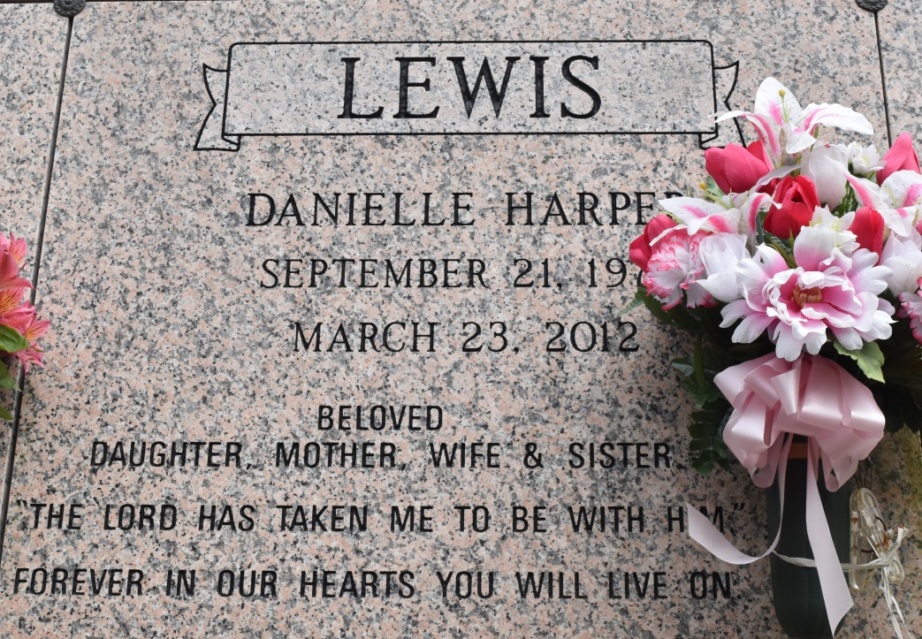

Danielle Harper-Lewis in Gonzales, LA., at 3:55 A.M., Friday, March 23, 2012. Daughter of "Coach" Arthur (Brenda) Harper, Jr. and Jacqueline Jacques (Paul) Goodwin. Wife of Edward Lewis, III. Beloved mother of Harper and Noah Lewis. Devoted sister of Monique and Wendell Harper. Also survived by aunts, uncles, cousins, other relatives and friends. Age 38.

Visiting at St. Michael's Catholic Church, Convent, LA., Thursday, March 29, 2012 from 9:30 A.M. until Mass of Christian Burial at 11:00 A.M. Entombment in St. Michael's Mausoleum. Brazier-Watson Funeral Home in charge of arrangements.

The Times-Picayune, New Orleans, Louisiana

Mar. 26 to Mar. 28, 2012