Gregory Paul Melancon Sr.
January 26, 1952 – January 29, 2022

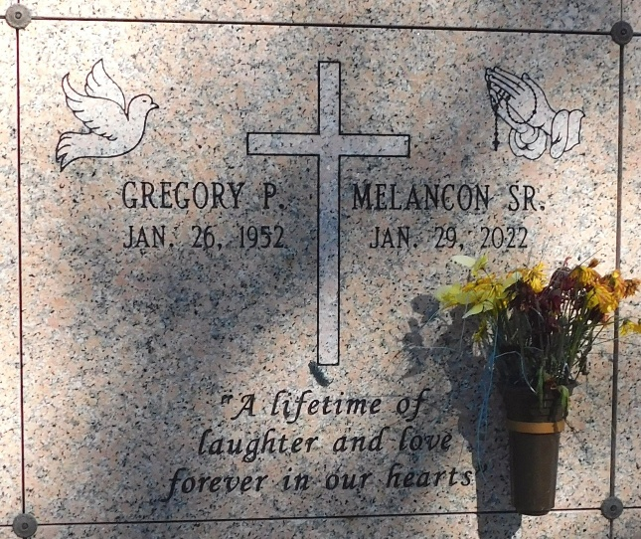
Photo by Mary Agnes Hammett

Gregory Paul Melancon, Sr. was born on January 26, 1952 to the late Lucy Beatrice and Joseph McFarland Melancon, Sr. Greg left his earthly home unexpectedly on Saturday, January 29, 2022.
Mr. Melancon is survived by his three Children: Gregory (Angela) Melancon, Jr. Tarikh (Jennifer) Melancon, and Brandy (Kingsley) Melancon, his grandchildren: Grier, Kyla, and Aleyna Melancon, his baby brother Arnold (Debra) Melancon, his aunt, Evangeline Lula Ishem, three sisters in law; Mary, Augustine, and Irma Melancon, one brother-in-law Irving Vancourt, Sr.
Funeral Service will be held on Saturday, February 12, 2022, beginning at 11:00 A.M. at True Light Worship Center 1012 West Orice Roth Road, Gonzales, LA, 70737. Bishop Adrien Claiborne, Pastor Officiating, Visitation begins at 10:00 A.M. until time of service.
Due to CDC (Covid-19) restrictions seating may be limited, mask and social distancing are required. Professional Services entrusted to the Caring Staff of Hobson Brown Funeral Home, 134 Daisy St., Garyville, La 70051, (985) 535-2516.
The Times-Picayune, New Orleans, Louisiana
Feb. 10 to Feb. 12, 2022

