Monique (Chatelain) Montz
January 21, 1971 – October 8, 2025

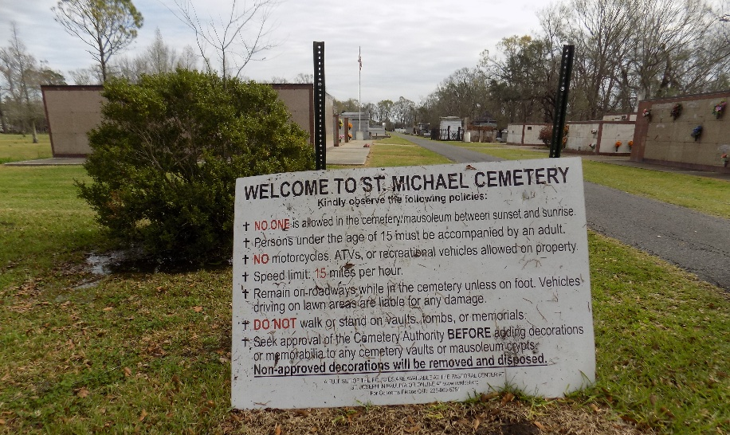

Monique Chatelain Montz, entered into eternal rest on October 8, 2025. Age 54 years and a lifelong resident of Paulina, LA. She is survived by her husband of 32 years, Doyle J. Montz. Beloved Mother of Laci Montz Rose. Mother-in-law of Seth Michael Rose and devoted Grandmother of Evelyn Ruth Rose. She is the daughter of Elaine Wherlin Chatelain, and the late Lionel Gabriel Chatelain, Jr. Sister of Lizette Holt (Kevin) and Godmother of Nicholas Louque (wife Nicole and children Owen, and Reece).
Monique shared a special bond with her husband and daughter but cherished her beautiful granddaughter Evelyn which was the light of her life. She enjoyed spending time with her family and friends and an occasional trip to the Casino with Doyle. She wasn't a southern master chef, but her cooking style would have made her one of the top Chefs. Monique loved her career and enjoyed working with the Gulf Mortgage Group for the past 20 years.
Relatives and friends of the family are invited to attend a Funeral Mass at St. Michael the Archangel Catholic Church, 6476 LA Highway 44, Convent, LA on Monday, October 13, 2025 at 11:00 AM. Visitation will begin at 9:00 AM until 11:00 at church. Interment will be in St. Michael's Cemetery.

H. C. Alexander Funeral Home, Norco, Louisiana

