Theresa (Green) Morris
1950 – August 17, 2023

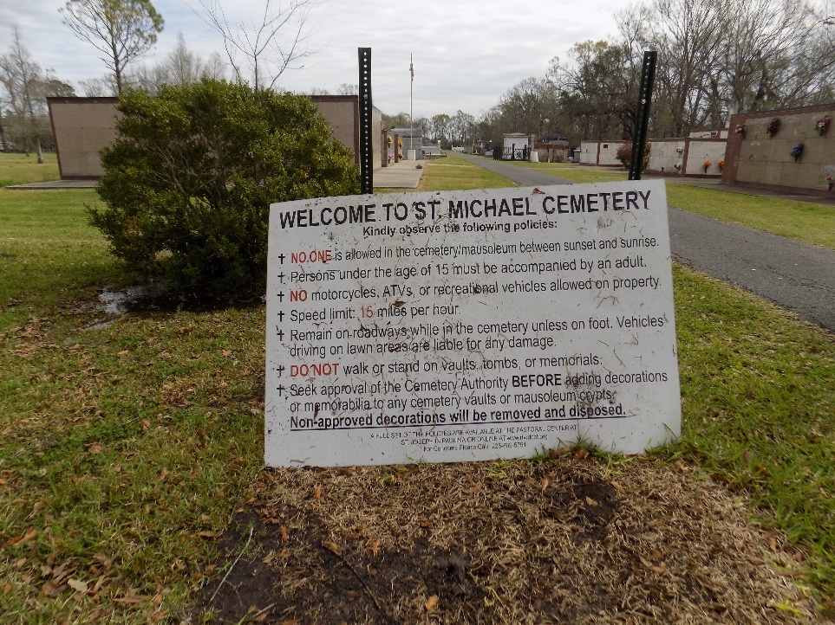

Theresa "Big Ma" Green Morris, age 73, departed this life on Thursday, August 17, 2023.
Daughter of the late Celestain Allen and Alfredia Green. Wife of the late Oscar Milton Morris. Mother of Keisha Morris. Sister of Carolyn Albert, Patricia, Doris, Bobby Ray, Robert Earl Green, and the late Rosetta, Regina, Alfred Celestain and Leonard Green. Theresa is also survived by a devoted friend, Alexander Davis, and a host other relatives and friends.
Funeral service will be held Saturday, August 26, 2023, at 11am at Young Pilgrim B.C., Rev. Thomas Scott Lane, Convent, LA, Rev. Wilma Jackson, Pastor Officiating. Visitation on Saturday from 10 am until services time. Interment: St. Michael Catholic Cemetery.
The Times-Picayune, New Orleans, Louisiana
Aug. 24 to Aug. 25, 2023

