Doris Nicholas

July 10, 1943 – May 5, 2015

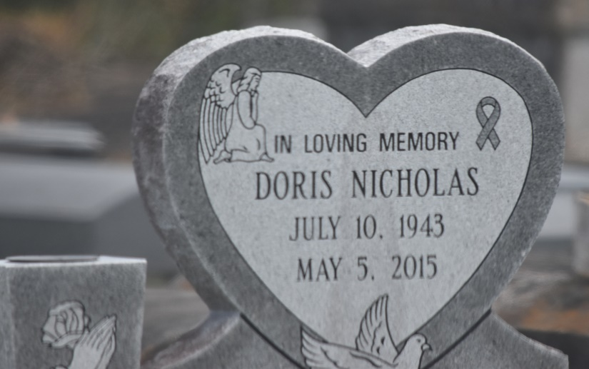

Doris Nicholas passed away on May 5, 2015, Mother of Kimly N. London, Edmond, Gregory, and Veronica Nicholas, also survived by 8 grandchildren, 4 great grandchildren, 3 sisters, 1 brother and a host of other relatives and friends.

Funeral services will be held on Saturday May 16, 2015 at 11:00a.m.at Pleasant Hill Baptist Church, 8238 Pleasant Hill Street, Convent, Louisiana. Rev. Roderick Williams pastor. Visitation at 9:00a.m. Interment in St. Michael Catholic Cemetery. Service Entrusted to Hobson Brown Funeral Home, Garyville, La. 70051 985-535-2516.

The Times-Picayune, New Orleans, Louisiana

May 14 to May 15, 2015