Dwayne Anthony Nicholas

April 18, 1970 – October 23, 2002

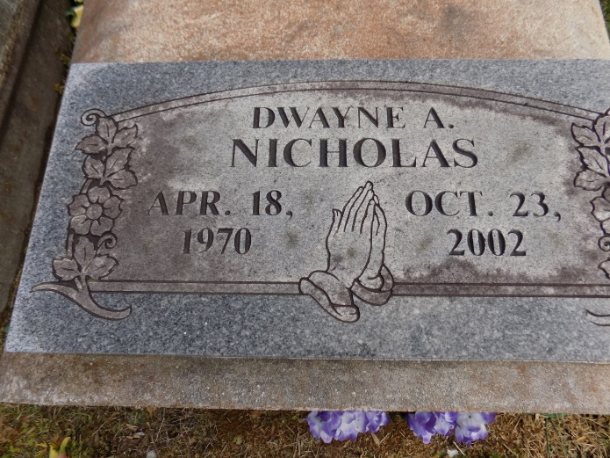

Dwayne Anthony Nicholas (Lulu) departed this life on Wednesday, October 23, 2002 at Our Lady of the Lake Hospital, Baton Rouge, LA. Son of Gladys Nicholas Vancourt of Convent, LA. Brother of Vanessa Myles, Samantha and Dennis Vancourt, Jr. all of Convent, LA. Survived by a host of nieces, nephews, aunts, uncles, other relatives and friends. A native and resident of Convent, LA. Age 32.

Relatives and friends of the family pastors, officers, and members of Pleasant Hill Baptist Church, and all neighboring churches, employees of American Eagle Co. are invited to attend the funeral service on Saturday, November 02, 2002 at 11:00 a.m. from the above named church, LA 44 and 8238 Pleasant Hill St. in Romeville, LA., Rev. Vergil Scott, Pastor officiating. Interment in St. Michael Cemetery, Convent, LA. Viewing at the church on Saturday at 9:00 a.m. until funeral time. Services Entrusted to HOBSON BROWN FUNERAL HOME.

The Times-Picayune, New Orleans, Louisiana

Nov. 1, 2002