Kim Marie (LeBlanc) Poche

December 18, 1952 – May 28, 2021

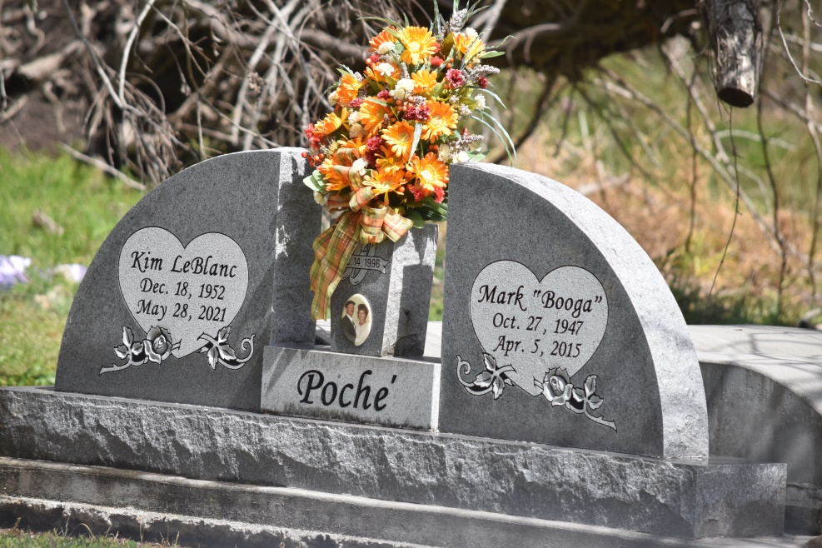

Kim Marie LeBlanc Poche’, a native of Reserve, LA and resident of Paulina, LA, passed away on Friday, May 28, 2021 at the age of 68.

Kim is survived by her children, Nathan Poche’ (Kelly), Marty Poche’ (Alison), and Janell (Keith) Chenier; grandchildren, Chelsea Poche’, Tiffanie Poche’, Payton Poche’, Kristen Poche’, Zack Poche’, Emily Chenier, and Jessi Chenier; siblings, Saundra “Pye” St. Pierre, Jill Vanlangendonck, Kerry LeBlanc (Anne) and Valerie LeBlanc; and several nieces and nephews.

She is preceded in death by her husband, Mark “Booga” Poche’; parents, Everett and Dorothy Haydel LeBlanc; and brothers-in-law, Stanislaus “Bubby” St. Pierre and Thomas Vanlangendonck.

She was a graduate of Leon Godchaux High School, Class of 1970.  She retired from Cargill Grain.  She was an active member of the St. James Boat Club and enjoyed traveling with her husband, boating, taking cruises, and other outdoor activities.

A visitation in Kim’s honor will be held on Wednesday, June 2, 2021 from 9:00 to 11:00 am at St. Michael the Archangel Catholic Church located at 6484 LA-44 in Convent, LA.  A Mass of Christian Burial will be held at 11:00 am with interment following in the St. Michael Cemetery.

Rose Lynn Funeral Home, LLC is in charge of the arrangements.

Rose Lynn Funeral Home

Lutcher, Louisiana